Playwright procedures to book a Private Motorcycling Training session

How to make a booking for a PRIVATE MOTORCYCLING LESSONS:

🎭 PLAYWRIGHT AUTOMATION FOR STEP 1:
// Navigate to the availability page
await page.goto('https://www.bookcbtnow.com/incontact/public/gateway.aspx?func_id=79A2A98E7C95DA57&obc_id=CFB644AFFB83F5C6');
// Wait for the availability table to load
await expect(page.locator('table, .availability-grid')).toBeVisible();
// Extract all available slots into structured data
const availableSlots = await page.locator('tr').evaluateAll(rows => {
return rows.slice(1).map(row => {
const cells = row.querySelectorAll('td');
return {
date: cells[0]?.textContent.trim(),
time: cells[2]?.textContent.trim(),
location: cells[1]?.textContent.trim(),
instructor: cells[cells.length-1]?.textContent.trim()
};
}).filter(slot => slot.date && slot.time);
});
// Return structured data to voice agent for natural conversation
return { availableSlots };
// Voice agent will ask client preferences and select appropriate slot
STEP 1 (for all workflows)

1. Firstly, you will need to find out the availability of our PRIVATE MOTORCYCLING LESSONS sessions through our live availability on the following weblink:

https://www.bookcbtnow.com/incontact/public/gateway.aspx?func_id=79A2A98E7C95DA57&obc_id=CFB644AFFB83F5C6
When you click on the above weblink this following webpage will show up:
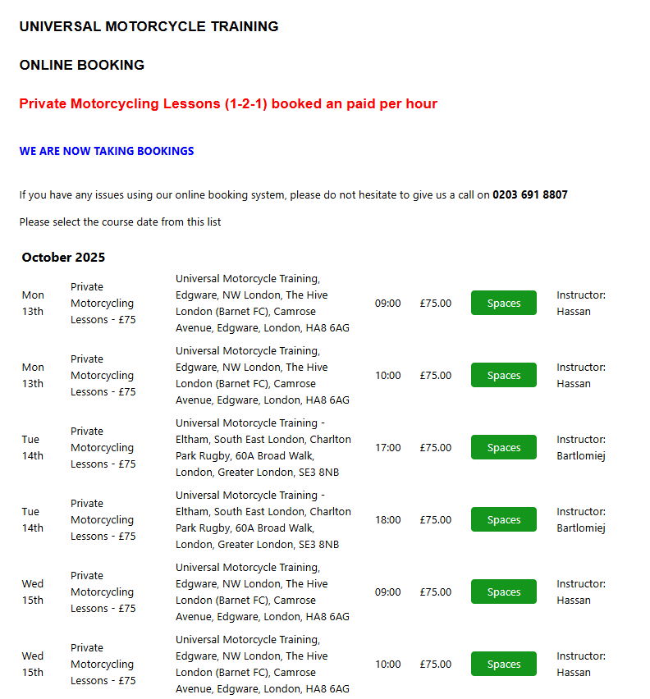
As you can see you will be able to offer to the client a training wherever and whenever we have availability.

To be more efficient you may ask the client:
(Question 1) “Do you have any preference of date or time?” For dates you will be looking on the fore most left column; for session starting time, you will be looking at the third column.
(Question 2) “Do you have any location preference?” For locations, you will be looking at the third column. For the avoidance of doubt, we currently have seven motorcycle training centres: (1) Alperton, HA0 4LR; (2) Croydon (CR0 4WT; (3) Dagenham, RM9 6XW; (4) Edgware, HA8 6AG; (5) Eltham, SE3 8NB; (6) Hoddesdon, EN11 0EH; (7) Wimbledon, KT3 4PH

(Question 3) “Do you have any instructor preference?” For the name of the instructors, you will be looking at last column on the far right of the screen.

Feel free to discuss with the client the availability as can be seen on this screen.
2. Once, you have agreed with the client as specific available session/course, and if the client agrees to proceed with the booking, then move on to the next step.

🎭 PLAYWRIGHT AUTOMATION FOR STEP 2 - AUTHENTICATION:
CRITICAL: Use persistent authentication to avoid repeated logins!
// First-time setup: Login and save state
if (!fs.existsSync('auth.json')) {
const context = await browser.newContext();
const page = await context.newPage();
await page.goto('https://takeabyte.co.uk/InContact/Account/Login');
// Use environment variables for credentials (NEVER hardcode!)
await page.getByLabel('Login name').fill(process.env.CRM_LOGIN || 'universalmct');
await page.getByLabel(/username.*email/i).fill(process.env.CRM_USERNAME || 'auagent');
await page.getByLabel('Password').fill(process.env.CRM_PASSWORD || 'Robert2025!');
await page.getByRole('button', { name: 'Login' }).click();
// Wait for successful login
await expect(page.locator('text=/Dashboard|Home|Welcome/i')).toBeVisible({ timeout: 10000 });
// Save authentication state for future use
await context.storageState({ path: 'auth.json' });
await context.close();
}
// Subsequent runs: Use saved authentication
const context = await browser.newContext({ storageState: 'auth.json' });
const page = await context.newPage();
await page.goto('https://takeabyte.co.uk/InContact');
// Verify we're logged in
await expect(page.locator('text=/Dashboard|Contacts|Diaries/i')).toBeVisible();
STEP 2 (for all workflows)

The next step is to login to the following CRM accessed via web browser.

1. Navigate to the following web page: https://takeabyte.co.uk/InContact/Account/Login

2. Once you arrive at the login screen, please find the required credentials below to access the CRM via browser:

🎭 PLAYWRIGHT LOCATORS FOR LOGIN FIELDS:
// Locate and fill login fields using robust locators
await page.getByLabel('Login name').fill(process.env.CRM_LOGIN);
await page.getByLabel(/username.*email/i).fill(process.env.CRM_USERNAME);
await page.getByLabel('Password').fill(process.env.CRM_PASSWORD);
// Click login button
await page.getByRole('button', { name: /login/i }).click();
// Verify successful login with assertion
await expect(page.getByText(/Dashboard|Welcome/i)).toBeVisible({ timeout: 10000 });
- login name: universalmct
- user name: auagent
- password: Robert2025!

On the login name shown in the picture below you need to write: universalmct


On the username or email shown in the picture below you need to write: auagent

On the password shown in the picture below you need to write: Robert2025!

3. Then, the next task is to click on the “Login” button as shown in the picture below:

Once you have successfully logged in, consider this step done, and move on to the next step.

🎭 PLAYWRIGHT AUTOMATION FOR STEP 3:
// This step is handled by the voice agent
// Voice agent asks: 'Have you done training with us before?'
// Based on client response, set workflow flag:
let workflowType = '';
if (clientResponse === 'yes') {
workflowType = 'existing';
} else if (clientResponse === 'no' || clientResponse === 'unsure') {
workflowType = 'new';
}
// Pass this flag to determine which automation path to follow
return { workflowType };
STEP 3 (for all workflows)

The next step is to ask the client the following question: “Have you done training with us before?” If the client sounds a bit confused or unsure, you may say to the client “Have done training with Universal Motorcycle Training before?”
If the client says: “Yes”, then follow the “Existing client workflow”.

If the client says: “No”, then follow the “New client workflow”.

If the client says: “I am unsure/don’t know”, then follow the “New client workflow”.

Existing client workflow

🎭 PLAYWRIGHT AUTOMATION FOR STEP 4 (EXISTING CLIENT):
// Navigate to Contacts section
await page.getByRole('link', { name: 'CONTACTS' }).click();
// Alternative if it's a button:
// await page.getByRole('button', { name: 'CONTACTS' }).click();
// Wait for the Find contacts page to load
await expect(page.getByText(/Find contacts/i)).toBeVisible();
STEP 4 (Existing client workflow)

This workflow is designed for:
- Existing clients: clients who have informed you that they have done training with Universal Motorcycle Training before.

This step consists of asking the client about his/her contact details so you can check if they already have done trainings with us before.
1. Your first task is to click on “CONTACTS” tab, located on the left column, as can be seen on the screenshot below:
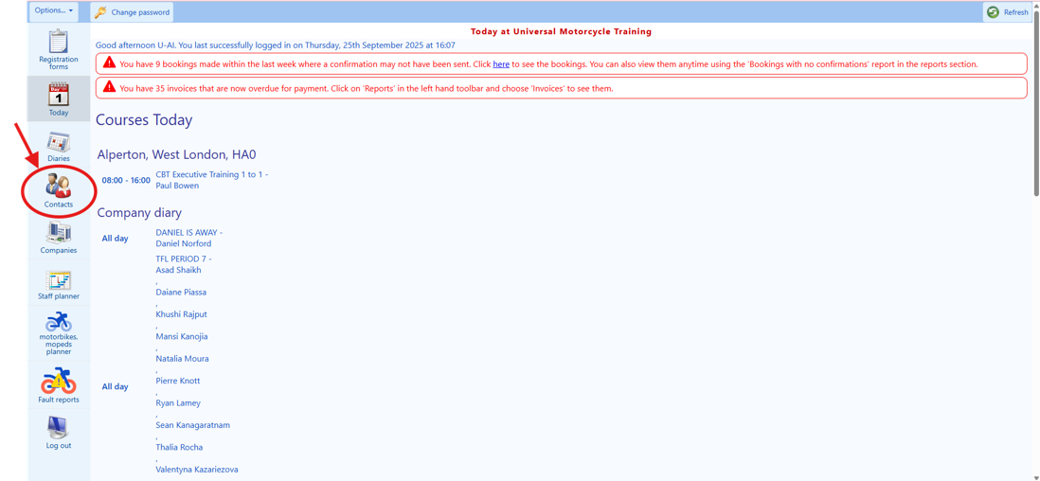
2. Then, on the “Find contacts” page will appear. Please see screenshot below:

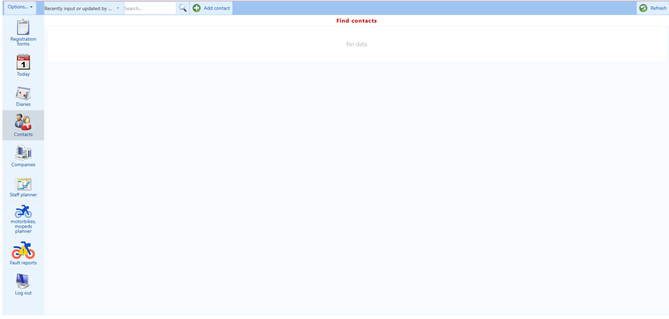

This page is the most important part for us to identify if the client is already part of our database or not.
3. Then, the next task is asking the client the following: “Have you done training with us before?” If the client answers “yes”, then follow the “existing client workflow”. However, if the client has answered “no”, then take the “new client workflow”.

🎭 PLAYWRIGHT AUTOMATION FOR STEP 5 (CLIENT SEARCH):
// Select Smart search from dropdown
await page.getByRole('combobox', { name: /Options/i }).selectOption('Smart search');
// Alternative if it's a different selector type:
// await page.locator('select').selectOption({ label: 'Smart search' });
// Fill in the search field with client's mobile number
const searchField = page.getByPlaceholder(/search/i);
await searchField.fill(clientMobileNumber);
// Wait for search results to appear
await page.waitForTimeout(1000); // Allow time for auto-search
// Check if client found
const searchResults = page.locator('.search-result, tr').filter({ hasText: clientMobileNumber });
const clientFound = await searchResults.count() > 0;
if (!clientFound) {
// Try with email address
await searchField.clear();
await searchField.fill(clientEmail);
await page.waitForTimeout(1000);
const emailResults = page.locator('.search-result, tr').filter({ hasText: clientEmail });
const foundByEmail = await emailResults.count() > 0;
if (!foundByEmail) {
// Try with name (first 3 letters of first name + space + first 3 letters of surname)
const nameSearch = clientFirstName.substring(0,3) + ' ' + clientSurname.substring(0,3);
await searchField.clear();
await searchField.fill(nameSearch);
await page.waitForTimeout(1000);
}
}
// If client found, click on their profile
if (clientFound) {
await searchResults.first().click();
// Extract client details for verification by voice agent
const clientDetails = {
name: await page.locator('.client-name, [data-field="name"]').textContent(),
postcode: await page.locator('.postcode, [data-field="postcode"]').textContent(),
phone: await page.locator('.phone, [data-field="phone"]').textContent()
};
// Return to voice agent for verbal verification
return { clientFound: true, clientDetails, requiresVerification: true };
}
return { clientFound: false };
STEP 5 (Existing client workflow)

If the client has informed you that it has done training with us before (existing client), then, the next step is to ask for their telephone number so that we may try to locate the client in the CRM by adding its full telephone.
🎭 PLAYWRIGHT CODE:
// Select Smart search option
await page.getByRole('combobox').selectOption('Smart search');
// Or: await page.locator('select').selectOption({ label: 'Smart search' });
// Fill search field
await page.getByPlaceholder(/search/i).fill(searchTerm);
1. The first task on this step is to select the option “Smart search” from the dropdown menu located on the top left of the screen (next to the “Options…” button).
2. Then, click on the “search…” field located next to the “Smart search” dropdown menu, and ask the client the following: “I will attempt to locate your profile in our systems. Therefore, may I please have your full mobile number?” Please see screenshot below:

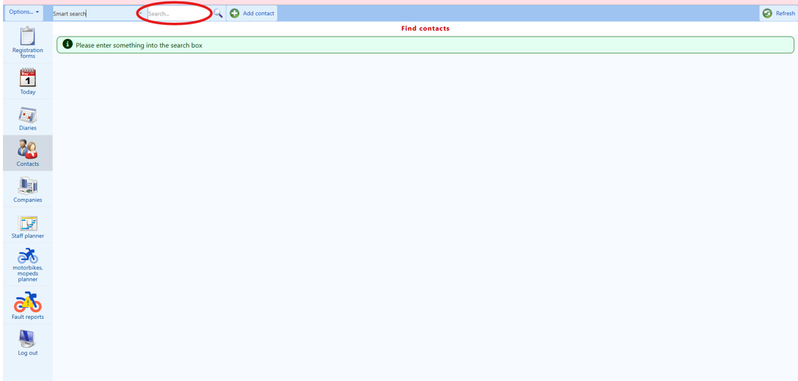

Please note: the mobile telephone numbers in the United Kingdom always starts with 07 and they have eleven characters in total (excluding the country code, if applicable, which is usually +44 for UK). As soon as you start typing the telephone numbers the system will start showing you the clients that have a telephone number starting with the same numbers as you can see on the next picture.
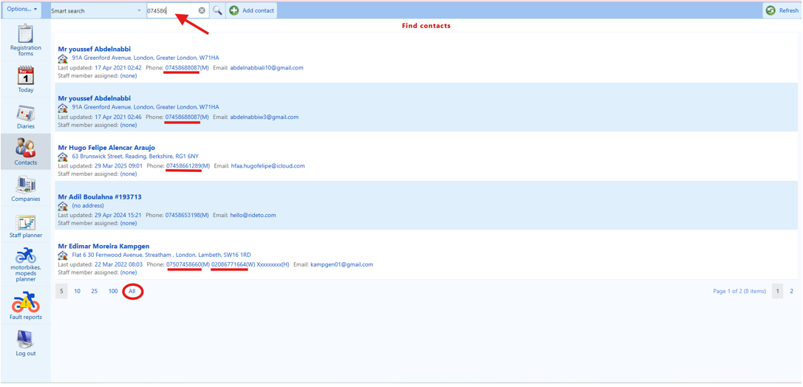
If you have typed the full mobile number and you did not find the client’s details, please ask the client “Unfortunately, I could not locate your profile with us with the provided mobile number, could you please repeat your full mobile number to me so that I can try again?” Once the client tells you the number, try again.
If you have typed the full mobile number for the second time and you did not find the client’s details, please ask the client “Unfortunately, I could not locate your profile with us with the provided mobile number, do you have or did you have an alternative phone number so that I can try again? Once the client tells you the number, try again.

If you could not find the client’s profile on the CRM via the mobile number on the third attempt, please ask the client the following question “I could not locate your customer profile with us with the provided mobile phone number, could you please provide me with your full email address?

🎭 PLAYWRIGHT CODE:
// Select Smart search option
await page.getByRole('combobox').selectOption('Smart search');
// Or: await page.locator('select').selectOption({ label: 'Smart search' });
// Fill search field
await page.getByPlaceholder(/search/i).fill(searchTerm);
Then, type the client’s email address on the same “search…” field located next to the “Smart search” dropdown menu, please see the screenshot below:
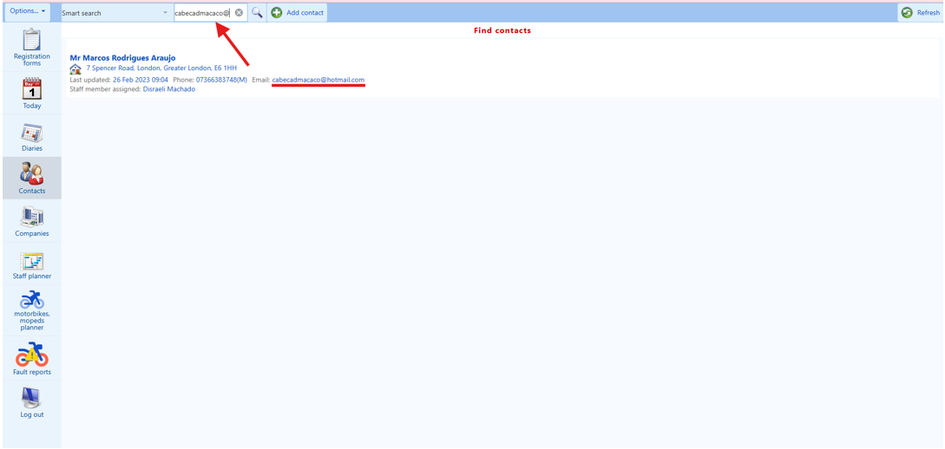

If you have successfully found the client's profile from his/her email address, you will say to the client: “Thanks for this; I believe that I have found your profile with us; However, for data protection purposes, could you please confirm: (1) your full name, (2) your post code, and (3) your telephone number?”

Then, once the client tells you these three pieces of information, you will need to check whether thy corresponds to what we have in our database (CRM) as shown on your current screen. If these three pieces of information are verbally confirmed by the client, from now on, you will consider the client as VERIFIED. If any of this information is incorrectly mentioned by the client, you will mention to the client which exact piece (or pieces of more than one) of information do not (or does not) correspond to what we have on file e.g.:

(1) if their full name does not match (excluding any reference numbers or symbols that may be present on their full name as this may be ignored), you will say to the client “Unfortunately, the full name that you have provided does not match the one that we hold on file for you; have you changed your name ,or have you perhaps previously provided a different spelling of your name to us?”

(2) if their post code does not match the one that you have on the CRM, you will say to the client “Unfortunately, the post code that you have provided does not match the one that we hold on file for you; have you changed your address, or have you perhaps previously provided a different postcode to us?”

(3) if the telephone number does not match the one that you have on the CRM, you will say to the client “Unfortunately, the telephone number that you have provided does not match the one that we hold on file for you; have you changed your telephone number or have you ever provided us with an alternative telephone number?”

You may provide up to seven chances to the client to correctly tell you a given piece of information e.g. (1) full name, (2) post code, and (3) telephone number.

Things to consider:
(A) Incorrect telephone number:
• If the telephone number is not the same as the client have provided to you, please confirm the last four digits of the telephone number and ask the client if that corresponds to his/her previous telephone number? Ask the client: “Could you please confirm the full telephone number of the telephone number that we have on file for you that ends with [then you will say the four last digits of their telephone number that we have on file as per the screen]?”

- If the client is able to tell you the full telephone number that we have for him/her on file, then this piece of information is verified, and if the other two pieces of information, namely, their full name and email address, have already been confirmed by the client then, from now on, you will consider the client VERIFIED.

After this, please ask the client whether he/she would like you to update their telephone number to the changed: if they say “no”, then no further action is required, and, therefore, you shall move on to the next step. However, if they say “yes”, you will be asking the client: “May I please have your new telephone number (mobile telephone number) so that we can update your details on our system (CRM)?” Once they tell you their new telephone number (please make sure that it is an 11-digit number, excluding the country code, which for the UK is usually +44), and please update it accordingly by accessing their profile as per Step 8.

(B) Cannot find the client via the email address:
• If you insert the email address that the client provides you, and you did not find the client’s information, the next step is to ask the client’s full name.

By typing the first 3 letters of his/her first name add a space and the 3 letters of his/her last name you may be able to find the client in our CRM. If you do not find the client, try to use the client’s middle name 3 letters instead of the last surname.

As can be seen on the screenshot below, the system will attempt to find the clients that matches the same name and surname as you can see in the red arrows and in the green arrows below:

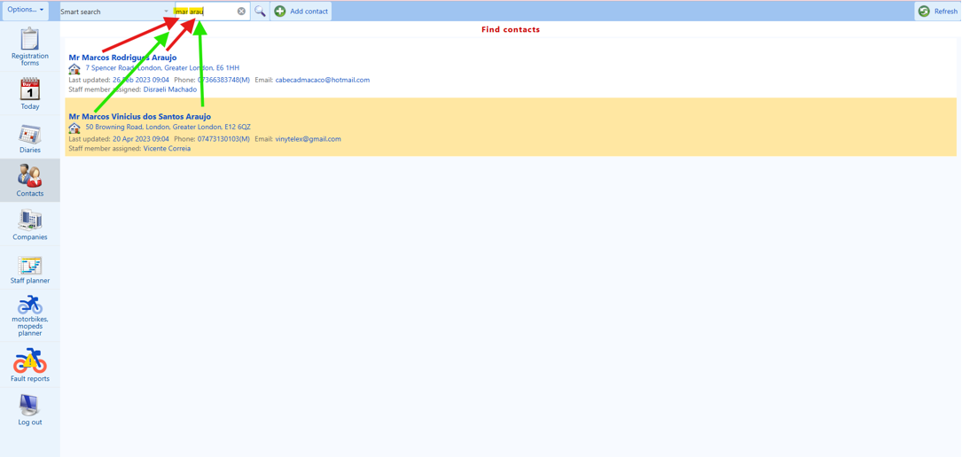
In the above example, they are two different clients with same first name and same last name. If that happens you need to confirm the (1) email address of the client, and (2) the postcode to see if that matches to what we have in the system. If these two pieces of information, namely, their email address and postcode, are confirmed by the client then, from now on, you will consider the client VERIFIED.

WARNING: never disclose any personal information from our clients found in our system with the client over the phone as it is against GDPR rules in the UK.

Once the client is VERIFIED, then, please move on to the next step. However, if the client remains unverified despite you providing him/her up to seven chances for information verification for any piece of information e.g. (1) full name, (2) post code, and (3) telephone number. Then, tell the client “Unfortunately, I am unable to gain access to your existing customer profile with us; however, I can create a new profile with us for you. Would you like me to proceed in creating a new customer profile with us?” If the client says “Yes”, then proceed to STEP 1 of “new client workflow”. If the client says “No”, then, advise the client that you are transferring the call to a colleague, then transfer the call to +442036918807.

🎭 PLAYWRIGHT AUTOMATION FOR STEP 6 (BOOKING CREATION):
// After client is VERIFIED, proceed to create booking
// Navigate to Diaries
await page.getByRole('link', { name: 'Diaries' }).click();
await expect(page.getByRole('heading', { name: /Diaries/i })).toBeVisible();
// Select the date (recall from Step 1)
const dateSelector = page.getByLabel(/date|calendar/i);
await dateSelector.click();
await page.getByRole('button', { name: agreedDate }).click();
// Or if it's a text input:
// await dateSelector.fill(agreedDate);
// Select training centre
const centreSelector = page.locator('select, [role="combobox"]').filter({ hasText: /location|centre/i });
await centreSelector.selectOption({ label: agreedLocation });
// Wait for diary to load with selected date and location
await page.waitForLoadState('networkidle');
STEP 6 (Existing client workflow)
Now that the existing client is VERIFIED, the next step is to get the client booked in the course according to the training that the client is interested in.

1. Your next task is to click on the “Diaries” button located on the left column on the screen, please see below:

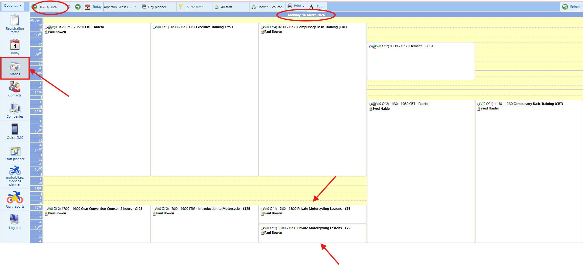

🎭 PLAYWRIGHT CODE:
// Locate and interact with date picker
const datePicker = page.getByLabel(/date|calendar/i);
await datePicker.click();
// Select the agreed date from Step 1
await page.getByRole('button', { name: agreedDate }).click();
// Or if it's a text input:
// await datePicker.fill(agreedDate); // Format: DD/MM/YYYY
2. Your next task is to find the date calendar selector located on the left-hand side of the top bar on the screen. Then, please recall the date which you have already discussed, verified availability, and agreed with the client during Step 1.
🎭 PLAYWRIGHT CODE:
// Select training centre from dropdown
const centreDropdown = page.locator('select').filter({ hasText: /location|centre/i });
await centreDropdown.selectOption({ label: agreedLocation });
// Wait for page to update
await page.waitForLoadState('networkidle');
3. Your next task is to select the training centre that you want to make the booking. The selection button for the training centres is next to the “Today” button located on the left-side of the top bar on the screen. Again, for this step, you will have to recall the training centre for the date and time of the course which you have already discussed, verified availability, and agreed with the client during Step 1. Please see screenshot below:
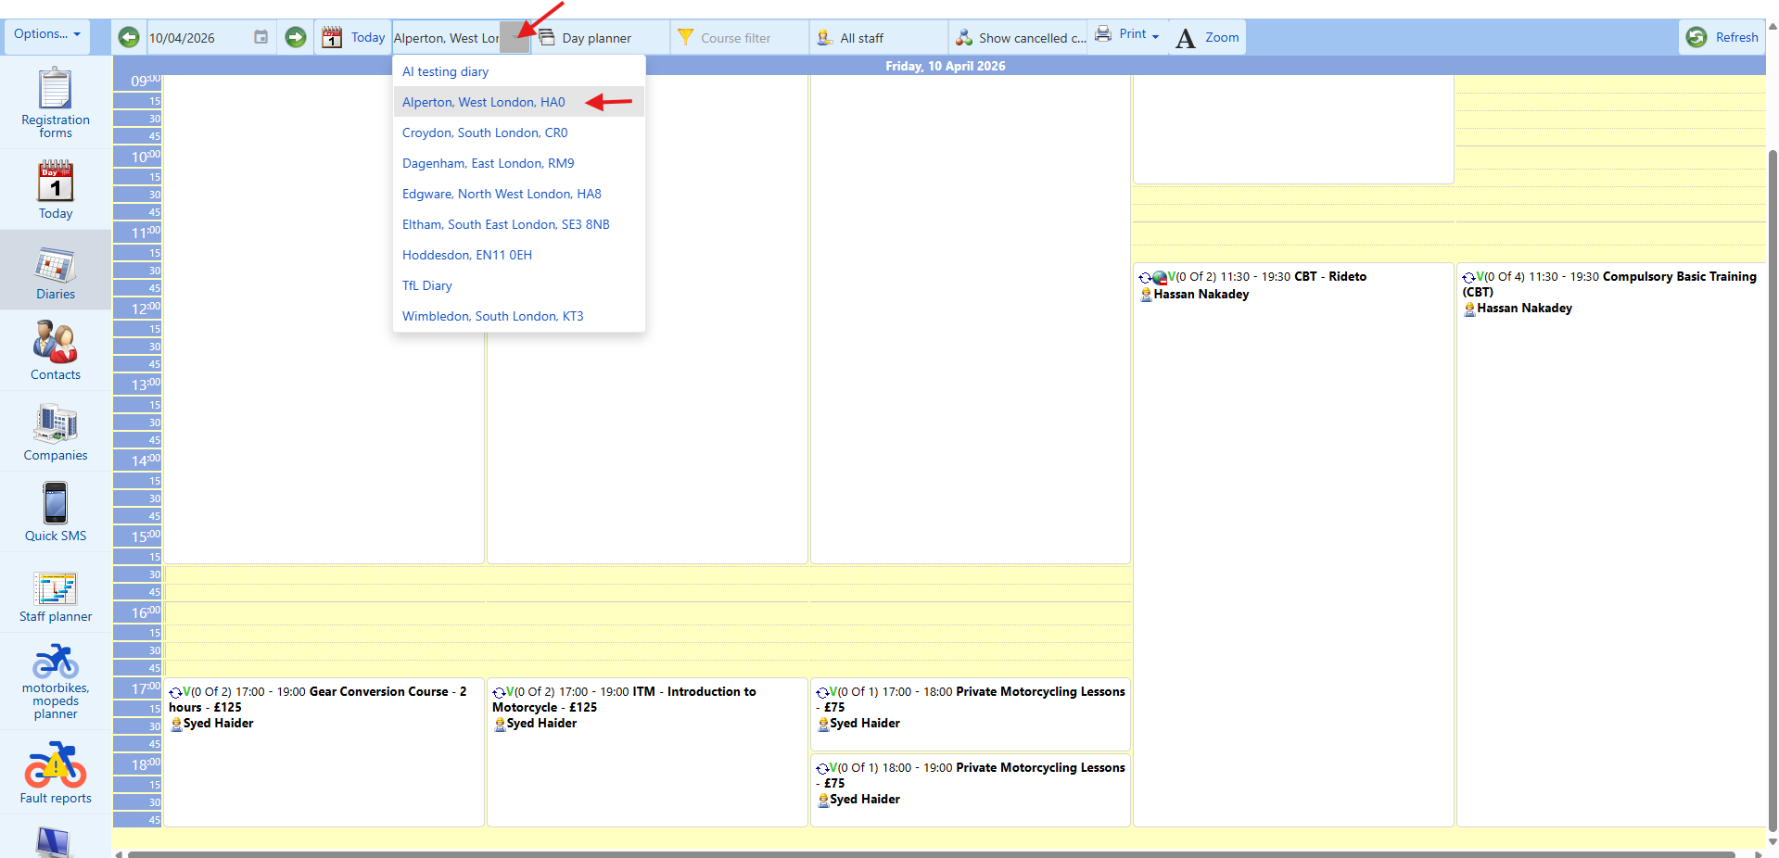

4. Once you have navigated to the correct date and training centre, then you will need to find the correct PRIVATE MOTORCYCLING LESSONS session which you have already discussed, verified availability, and agreed with the client during Step 1.

🎭 PLAYWRIGHT CODE:
// Locate the specific session frame using filters
const sessionFrame = page.locator('.session, .booking-slot, tr').filter({
hasText: agreedTime
}).filter({
hasText: agreedLocation
});
// Click on the session
await sessionFrame.click();
// Wait for popup menu to appear
await expect(page.getByRole('button', { name: 'NEW BOOKING' })).toBeVisible();
5. Once you have found the correct PRIVATE MOTORCYCLING LESSONS session, then left click anywhere on the white part of this specific session frame.

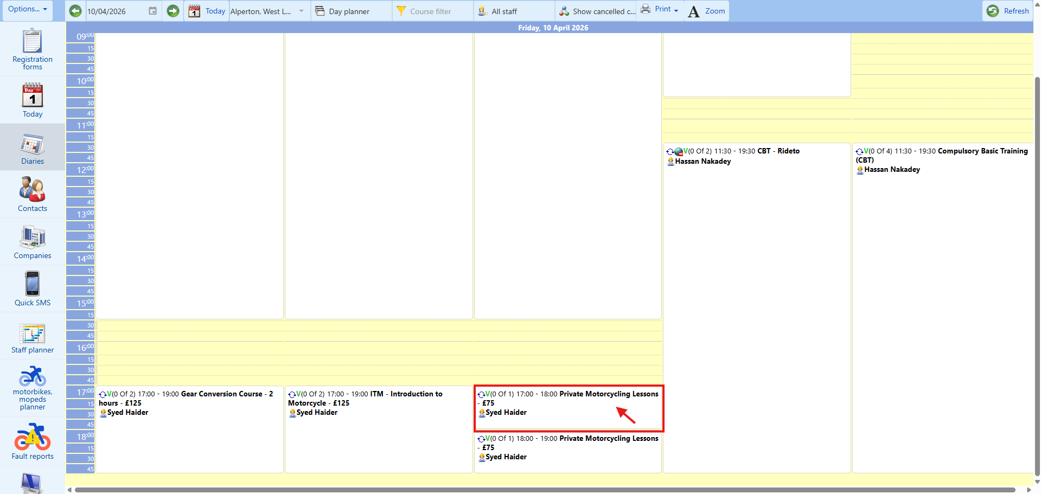

🎭 PLAYWRIGHT CODE:
await page.getByRole('button', { name: 'NEW BOOKING' }).click();
await expect(page.getByRole('heading', { name: /Price|Booking/i })).toBeVisible();
6. A pop-up menu will appear, and your task is to click on the “NEW BOOKING” button on the pop-up menu, please see screenshot below:

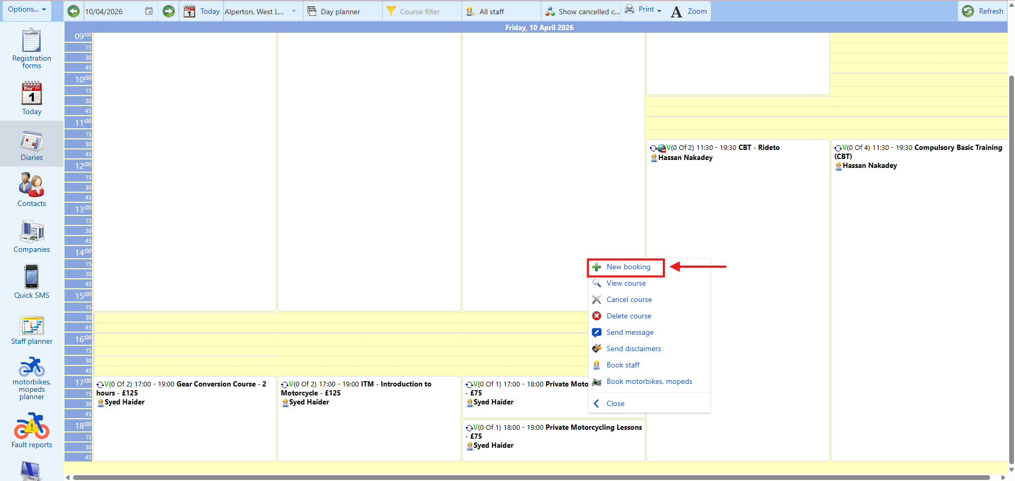

🎭 PLAYWRIGHT AUTOMATION FOR STEP 7 (BOOKING OPTIONS):
// Wait for Price page to load
await expect(page.getByRole('heading', { name: /1\. Price/i })).toBeVisible();
// Scroll to booking options section
await page.locator('text=/Booking options/i').scrollIntoViewIfNeeded();
// Select bike type based on client's choice
const bikeTypeMap = {
'125cc automatic': '125cc automatic (scooter)',
'50cc automatic': '50cc automatic',
'125cc manual': '125cc manual (geared)',
'500cc restricted': '500cc restricted Bike',
'600cc': '600cc'
};
const selectedBikeType = bikeTypeMap[clientBikeChoice];
await page.getByRole('radio', { name: new RegExp(selectedBikeType, 'i') }).check();
// Verify selection
await expect(page.getByRole('radio', { name: new RegExp(selectedBikeType, 'i') })).toBeChecked();
// Click NEXT button
await page.getByRole('button', { name: 'NEXT' }).click();
// Wait for contact selection page
await expect(page.getByText(/Contact|Lookup contact/i)).toBeVisible();
STEP 7 (Existing client workflow)
1. Then, you will be shown a new page which should say “1. Price” on the top of the screen, please see screenshot below:

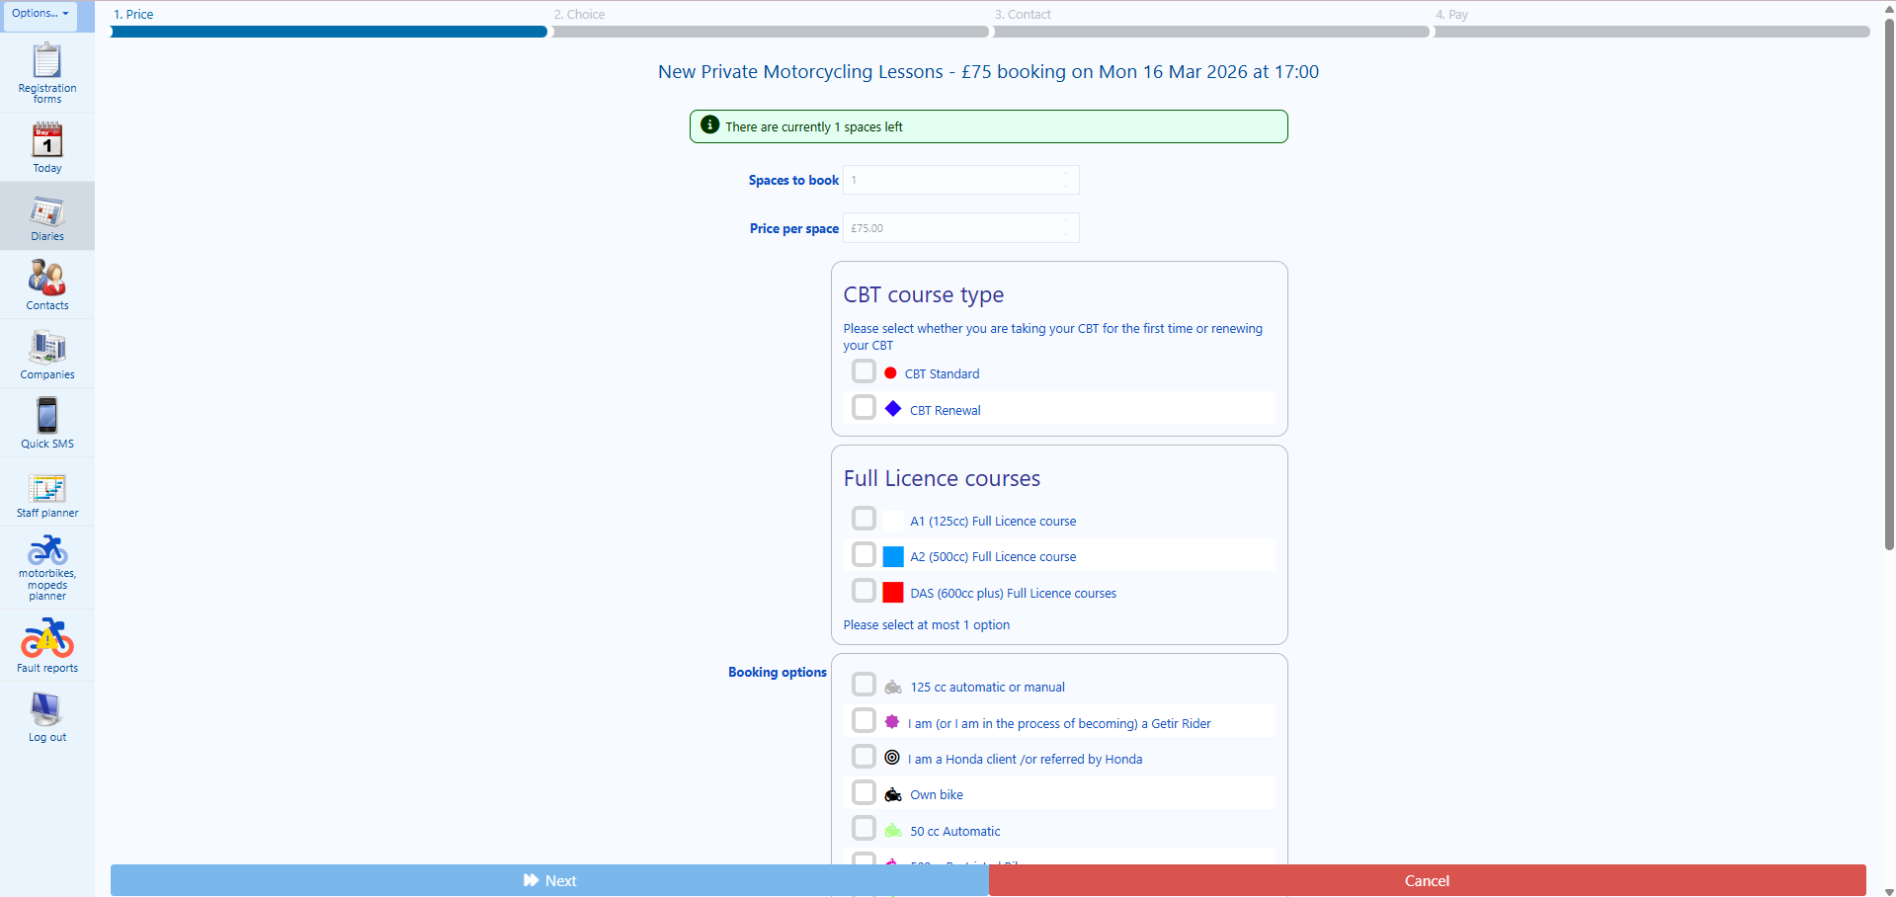

🎭 PLAYWRIGHT CODE:
// Select bike type radio button
await page.getByRole('radio', { name: /125cc automatic.*scooter/i }).check();
// Or for other options:
// await page.getByRole('radio', { name: /50cc automatic/i }).check();
// await page.getByRole('radio', { name: /125cc manual.*geared/i }).check();
// await page.getByRole('radio', { name: /500cc restricted/i }).check();
// await page.getByRole('radio', { name: /600cc/i }).check();
// Click NEXT
await page.getByRole('button', { name: 'NEXT' }).click();
2. Then, your next task is to scroll down the page and find “Booking options”. Once on this screen, you will ask the client whether he/she wants to do the course on a “125cc automatic (scooter)” or on a “50cc automatic” or on a “125cc manual (geared)”, on “500cc restricted Bike”, or on “600cc”. Despite having more options on the screen, you will only provide the client with these five options. Once the client informs you his choice then, your next task is to click on the “NEXT” button, please see screenshot below:

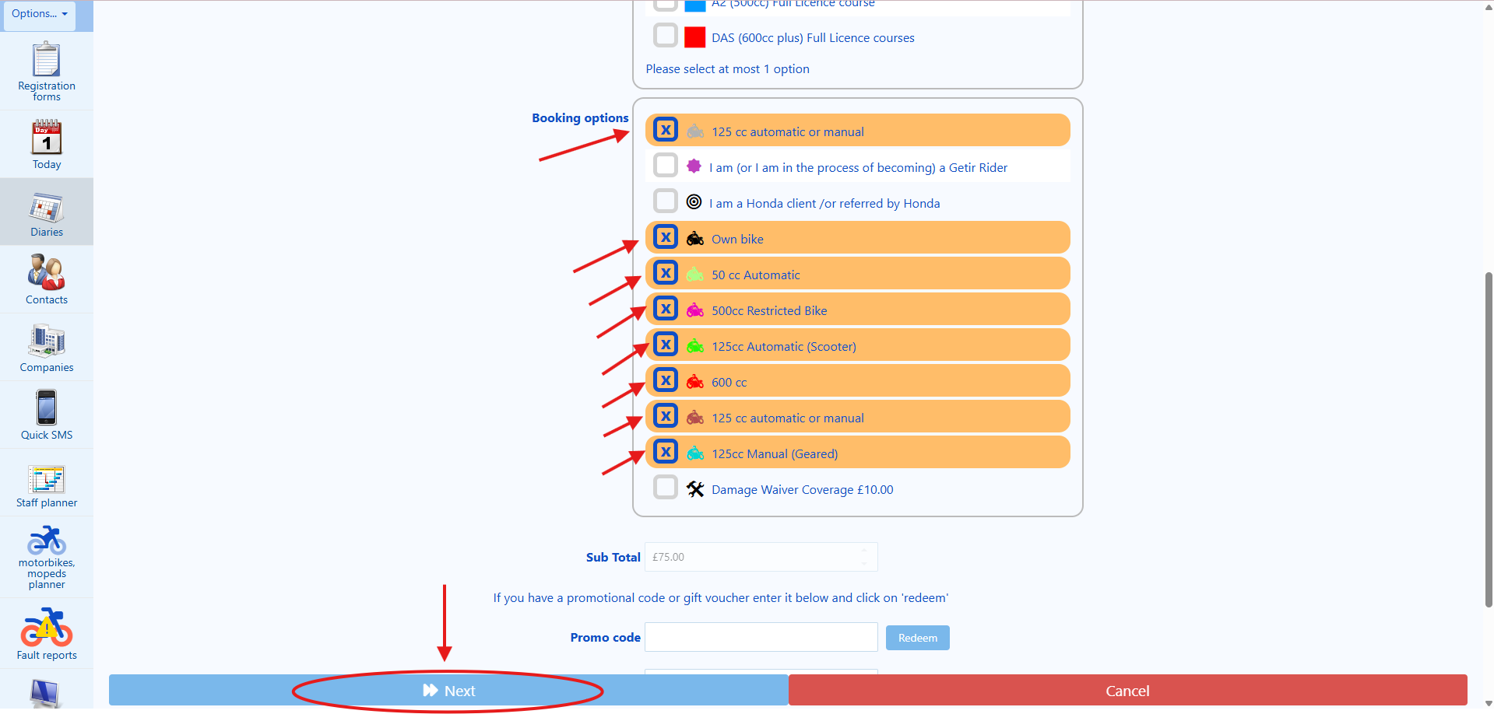

3. Then, another window will appear with the following information:

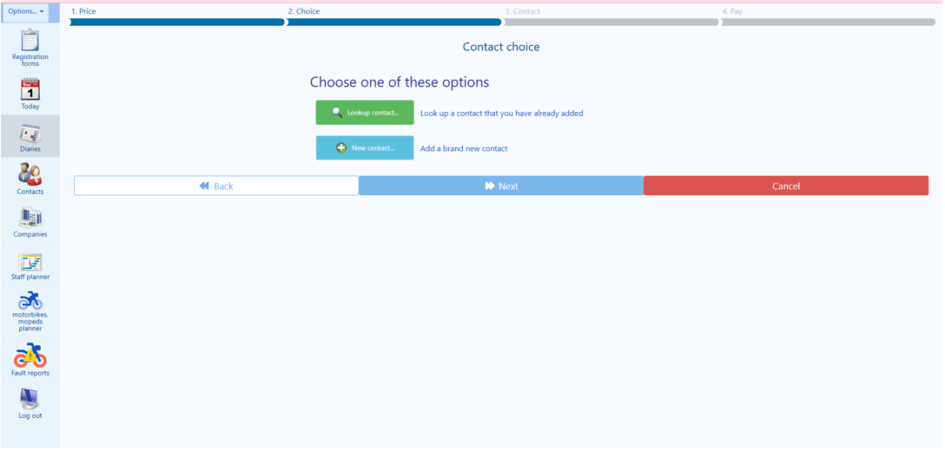

As can be seen in the picture above, you will have two options:

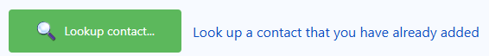
And
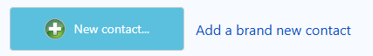
🎭 PLAYWRIGHT CODE:
// For existing verified client
if (clientVerified) {
await page.getByRole('button', { name: 'Lookup contact' }).click();
// Search for client again
await page.getByPlaceholder(/search/i).fill(clientIdentifier);
await page.waitForTimeout(1000);
// Click on client profile
await page.getByText(clientName).click();
} else {
// For new client
await page.getByRole('button', { name: 'New contact' }).click();
}
As we have two options, we need to understand which one will apply to make this booking. I will show you first how to use the “Lookup contact” function if you have already found the client’s profile on the previous steps and if the client is already VERIFIED, then, if this is the case, your task is to click on the “Lookup contact” button. If not, e.g. if the client is not yet VERIFIED then go back to Step 5.

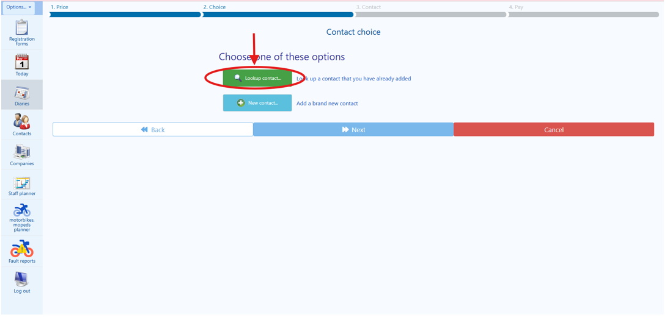

4. Then, your next task is to click on the downward arrow next to the field “Search”, as indicated in the screenshot below:

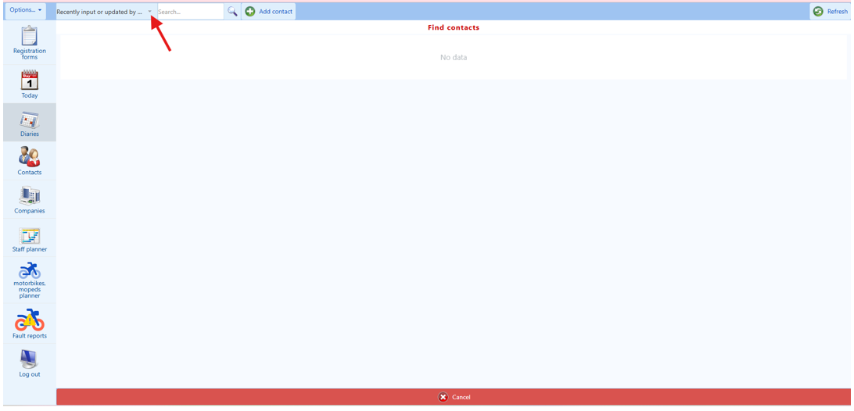
5. Then, from the dropdown list, please select the best option according with the information that you already have from the client (who is already VERIFIED by you) in order to again find and then access the client’s profile.

TIP 1:
• Go to the SMART SEARCH first as it can match the client’s telephone number, email address (if you type the email address up to the @), it can find the client's name and surname. I have already explained in this guidance on how to search the name of the client, the email address, and by their telephone numbers, please refer to the instructions provided above as it is the same. However, if this option does not help, then chose the “First name begins with” option from the drop-down menu, and then, ask the client his/her first name. and type on the “search…” bar, please see screenshot below:

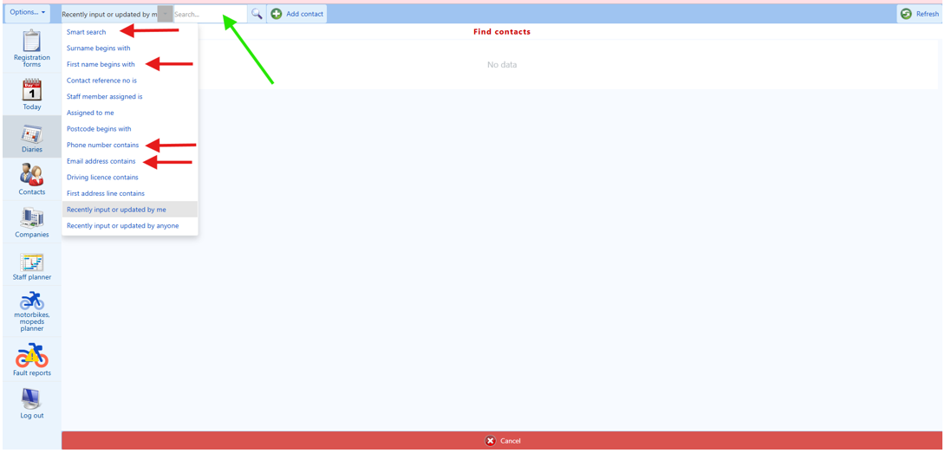
TIP 2:
If the client’s first name does not appear, then try the surname, the telephone number, email address, try to ask the client for his/her driving licence number which starts with the 5 letters of his/her surname, there are a sequence of 6 numbers then one or two letters, after that a number and two letters at the end, and it is number 5 on the licence.

The SMART SEARCH only works with the name of the client, telephone number or email address. If you check the name of the client, you can type the first three or four letters of the first name and the first three or four letters of the last name with one space in between them.

6. If you have found the client on the SMART SEARCH, your next task is to click on the name of the client as can be seen on the screenshot below:

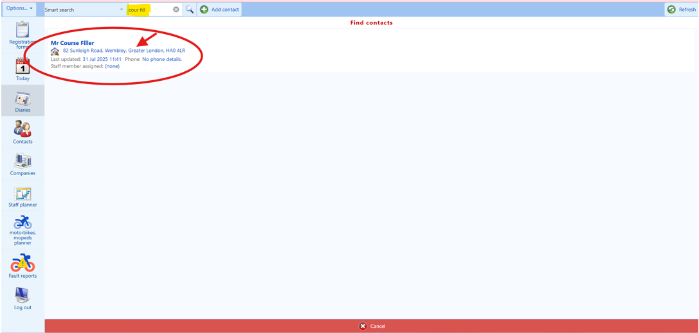

🎭 PLAYWRIGHT AUTOMATION FOR STEP 8 (CONTACT DETAILS):
// Wait for Contact page to load
await expect(page.getByRole('heading', { name: /3\. Contact/i })).toBeVisible();
// Check for missing fields and fill them
const fieldsToCheck = [
{ label: 'Contact e-mail', value: clientEmail, voicePrompt: 'email address' },
{ label: 'Contact mobile number', value: clientMobile, voicePrompt: 'mobile number' },
{ label: 'Post code', value: clientPostcode, voicePrompt: 'postcode' },
{ label: 'House number or name', value: clientHouseNumber, voicePrompt: 'house number' },
{ label: 'National Insurance number', value: clientNI, voicePrompt: 'National Insurance number' },
{ label: 'Driving licence number', value: clientDLN, voicePrompt: 'driving licence number' }
];
for (const field of fieldsToCheck) {
const fieldLocator = page.getByLabel(field.label);
const currentValue = await fieldLocator.inputValue();
if (!currentValue || currentValue.trim() === '') {
// Field is missing - voice agent should ask client
// Then fill the field
await fieldLocator.fill(field.value);
// Verify the value
await expect(fieldLocator).toHaveValue(field.value);
}
}
// Special handling for House number (triggers address auto-population)
const houseField = page.getByLabel('House number or name');
await houseField.fill(clientHouseNumber);
await houseField.press('Tab');
// Wait for Address 1 to auto-populate
await page.waitForTimeout(2000);
const address1 = await page.getByLabel('Address 1').inputValue();
// Return to voice agent for confirmation
return { address1, requiresConfirmation: true };
Step 8 (Existing client workflow)

1. After clicking on the client’s profile (thus, selecting it) you will be taken to the “3. Contact” screen, please see screenshot below:

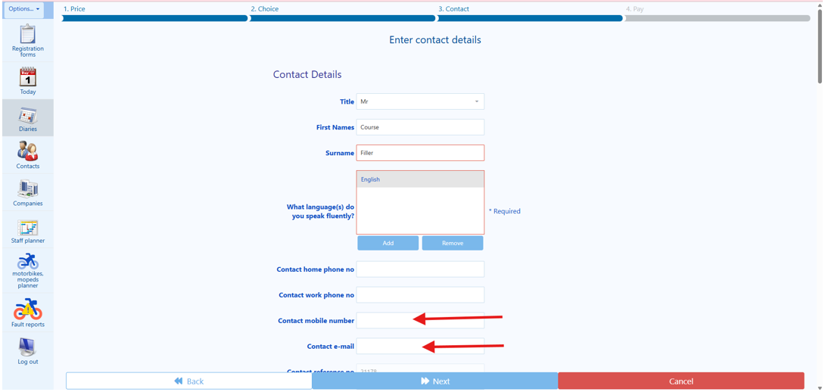
2. If you see that there is the following missing information on the client’s profile: “Contact email address”, “contact mobile number”, “post code”, “house number or name”, “licence held”, “national insurance number”, or “driving licence number”. Your task is to ask the client for the missing information. According to the missing information field, you may ask the client the following questions:

🎭 PLAYWRIGHT CODE:
await page.getByLabel('Contact e-mail').fill(clientEmail);
await expect(page.getByLabel('Contact e-mail')).toHaveValue(clientEmail);
When a “contact e-mail address” is missing: “I can see in your profile that we currently don’t have your email address; could you please provide me with your full email address?” Then, your task is to populate the “contact e-mail address” field. So, once you have populated the “Contact e-mail” field, please ask the client: “Could you please confirm to me your full email address again?” Then, proceed in double checking what you have populated in the field “Contact email” before moving on to the next missing field or task.

🎭 PLAYWRIGHT CODE:
await page.getByLabel('Contact mobile number').fill(clientMobile);
// UK mobile: 11 digits starting with 07
await expect(page.getByLabel('Contact mobile number')).toHaveValue(clientMobile);
When a “contact mobile number” is missing: “I can see in your profile that we currently don’t have your mobile number; could you please provide me with your full mobile number?” Then, your task is to populate the “contact mobile number” field. However, if you the client has provided you with a mobile number that has more than eleven digits or less than eleven digits, please ask the client: “Could you please tell me your mobile number again?” Then, proceed in double checking what you have populated in the field “Contact mobile number” before moving on to the next missing field or task.

🎭 PLAYWRIGHT CODE:
await page.getByLabel('Post code').fill(clientPostcode);
await expect(page.getByLabel('Post code')).toHaveValue(clientPostcode);
When a “Post Code” is missing: “I can see in your profile that we currently don’t have your Post Code; could you please provide me with your post code?” Then, your task is to populate the “Post Code” field. So, once you have populated the “Post code” field, please ask the client: “Could you please confirm to me your post code again?” Then, proceed in double checking what you have populated in the field “Post code” before moving on to the next missing field or task.

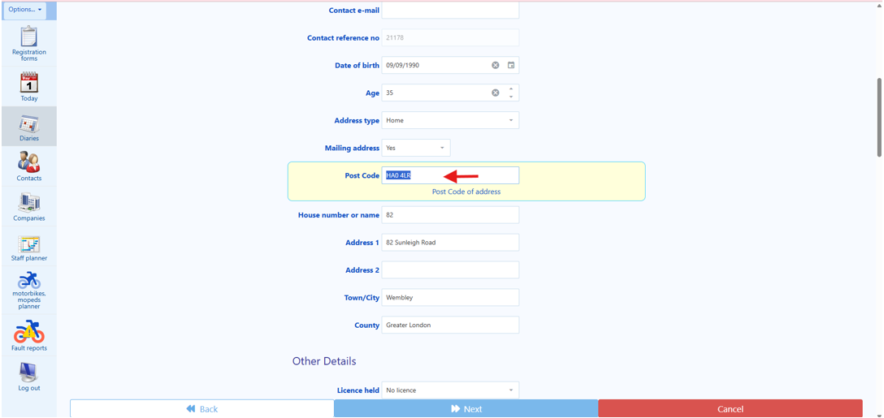

🎭 PLAYWRIGHT CODE:
// Fill house number and trigger auto-population
await page.getByLabel('House number or name').fill(houseNumber);
await page.getByLabel('House number or name').press('Tab');
// Wait for auto-population (2 seconds)
await page.waitForTimeout(2000);
// Extract auto-populated address
const address1 = await page.getByLabel('Address 1').inputValue();
const townCity = await page.getByLabel('Town/City').inputValue();
// Return to voice agent for confirmation
return { address1, townCity, requiresVoiceConfirmation: true };
When a “House number or name” is missing: “I can see in your profile that we currently don’t have your house number or name; could you please provide me with your house number or house name?” Then, your task is to populate the “House number or name” field. The house number or name is an important piece of information. So, once you have populated the “House number or house name” field, please ask the client: “Could you please confirm to me your house number or house name?” Then, whilst still being on the already populated “House number or name” field, and before you click away from this field, press the “TAB” key on your keyboard, and wait until the “Address 1” field is populated (usually this takes one or two seconds. Then, read the first line of the address now self-populated in the field “Address 1” back to the client, you may say: “I believe that I now have the first line of your address, is it…” then, proceed by reading to the client the self-populated information contained in the field “Address 1” field. Then, ask the client: “Was this the correct first line of your address?” If the client says “yes”, proceed to the next task. If the client says “no”, then erase the information that was self-populated on the field “Address 1” and replace it with the information that the client has given you. The “Address 1” field is an important piece of information. So, once you have manually populated the “Address 1” field, please ask the client: “Could you please confirm to me the first line of your address?” Then, proceed in double checking what you have populated in the field “House number or house” before moving on to the next missing field or task.

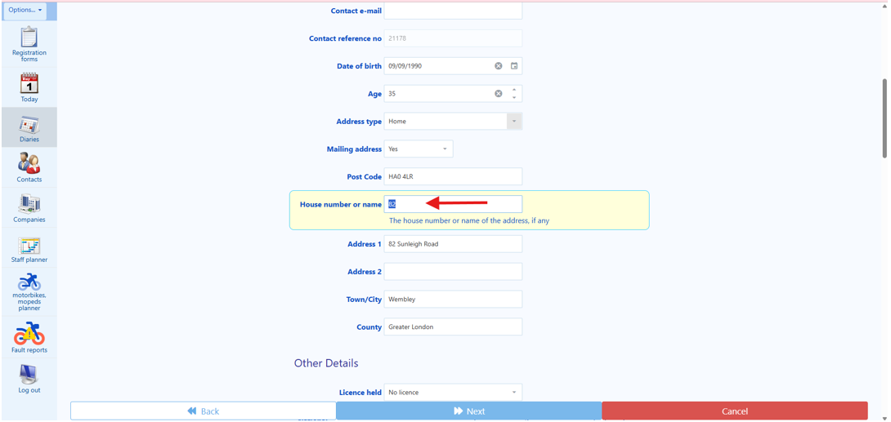

When a “Licence held” is missing: “I can see in your profile that we currently don’t have the type of driving licence that you have; which driving licence do you have?” Then, your task is, from the drop-down list, please choose the option that best suits the client’s answer.

🎭 PLAYWRIGHT CODE:
await page.getByLabel('National Insurance number').fill(clientNI);
// Format: AB 12 34 56 C (2 letters, 6 digits, 1 letter)
await expect(page.getByLabel('National Insurance number')).toHaveValue(clientNI);
When a “National Insurance number” is missing: “I can see in your profile that we currently don’t have your National Insurance number; could you please provide me with your National Insurance number?” Then, your task is to populate the “National Insurance number” field.

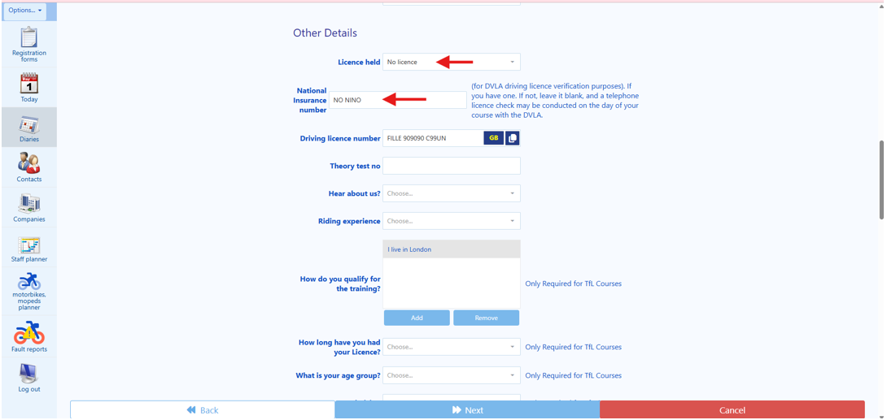
🎭 PLAYWRIGHT CODE:
// Check if GB or NI licence format needed
if (clientLicenceFormat === 'NI') {
await page.getByRole('button', { name: 'GB' }).click(); // Switch to NI format
}
await page.getByLabel('Driving licence number').fill(clientDLN);
await expect(page.getByLabel('Driving licence number')).toHaveValue(clientDLN);
When a “Driving licence number” is missing: “I can see in your profile that we currently don’t have your driving licence number; could you please provide me with your driving licence number?” Then, your task is to populate the “Driving licence number” field.

Tip: Some clients might have a Northern Ireland driving licence which has only eight digits numbers on it without any letters. If that is the case, please refer to the next picture.

Click on the button “NI” as outlined on the screenshot below, and then the driving licence format will automatically change to Northern Ireland format in the CRM system.

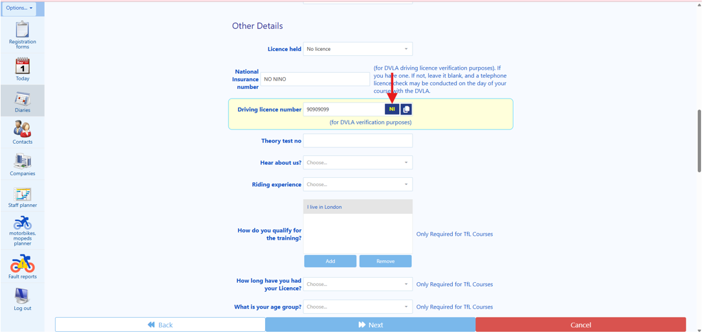

🎭 PLAYWRIGHT CODE:
await page.getByLabel('Hear about us').selectOption({ label: clientSource });
3. Next, we will be moving to the “Hear about us” field. Therefore, you will ask the client: “How did you hear about us?” On the dropdown list, choose the option that best approximates to what the client has told you, please see screenshot below:

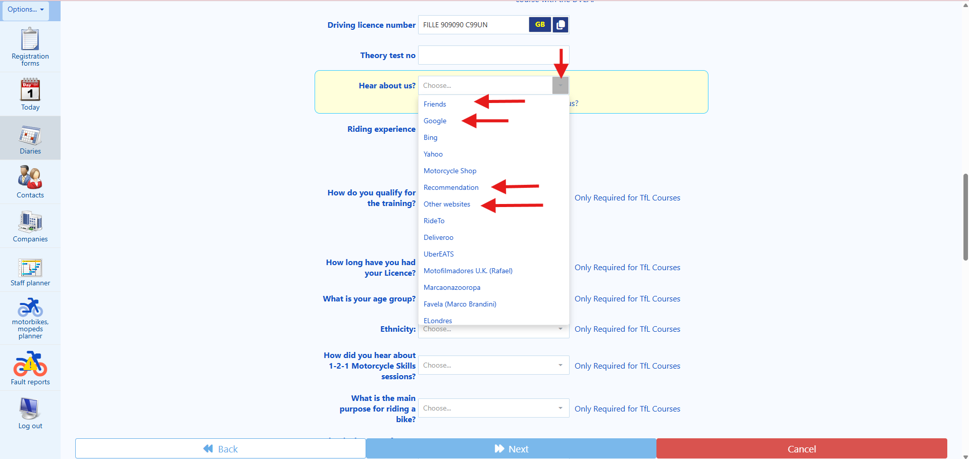
🎭 PLAYWRIGHT CODE:
await page.getByLabel('riding experience').selectOption({ label: clientExperience });
// Options: 'None but can ride a push bike', 'Some but a while ago',
// 'Some recently', 'Some/medium experience', 'Had a previous CBT', 'Experienced rider'
4. The next field is the “riding experience”. From the dropdown list, choose the option that best approximates to what the client has told you. Regarding the field “riding experience”, 99.99% of the clients will be in one of the following categories:

None but can ride a push bike This person has never ridden a motorcycle before and just used a bicycle in his/her life.

Some but a while ago This person might have ridden a motorcycle only once or twice in his/her life or maybe used a motorcycle abroad (Consider difference of rules and regulations of UK Highway Code).

Some recently This person might have ridden a motorcycle either in the UK (on a private land or racing track or under an International Driving Licence) or abroad, it is important to ask the client about it as to understand the level of experience they have when they are trying to book the course with us so we can give them the correct advice.

Some/medium experience This person had a previous riding experience abroad, or this person is riding a motorcycle at present (e.g. under an International Licence or in private land). This person might have ridden a large motorcycle in the past/recently.

Had a previous CBT This person had completed a CBT in the past and is due to renew it.

Experienced rider This person might have completed the full motorcycle licence, either abroad or in the UK and might have lost the licence for some reason and now need to book a CBT training again.
Your task here is to ask the client and then choose from the dropdown list, the option that best approximates to what the client has told you, please see screenshots below:

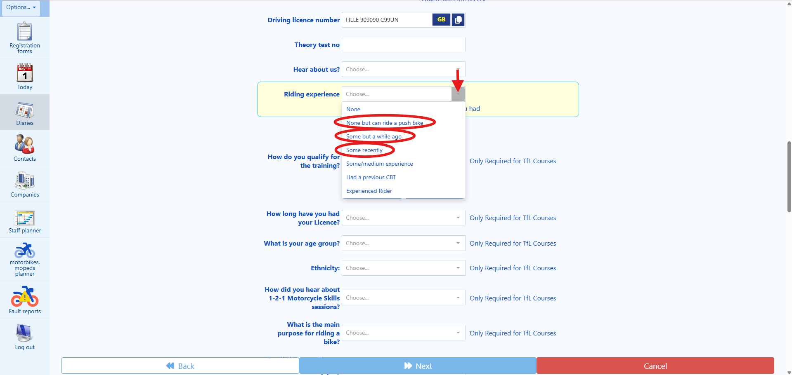

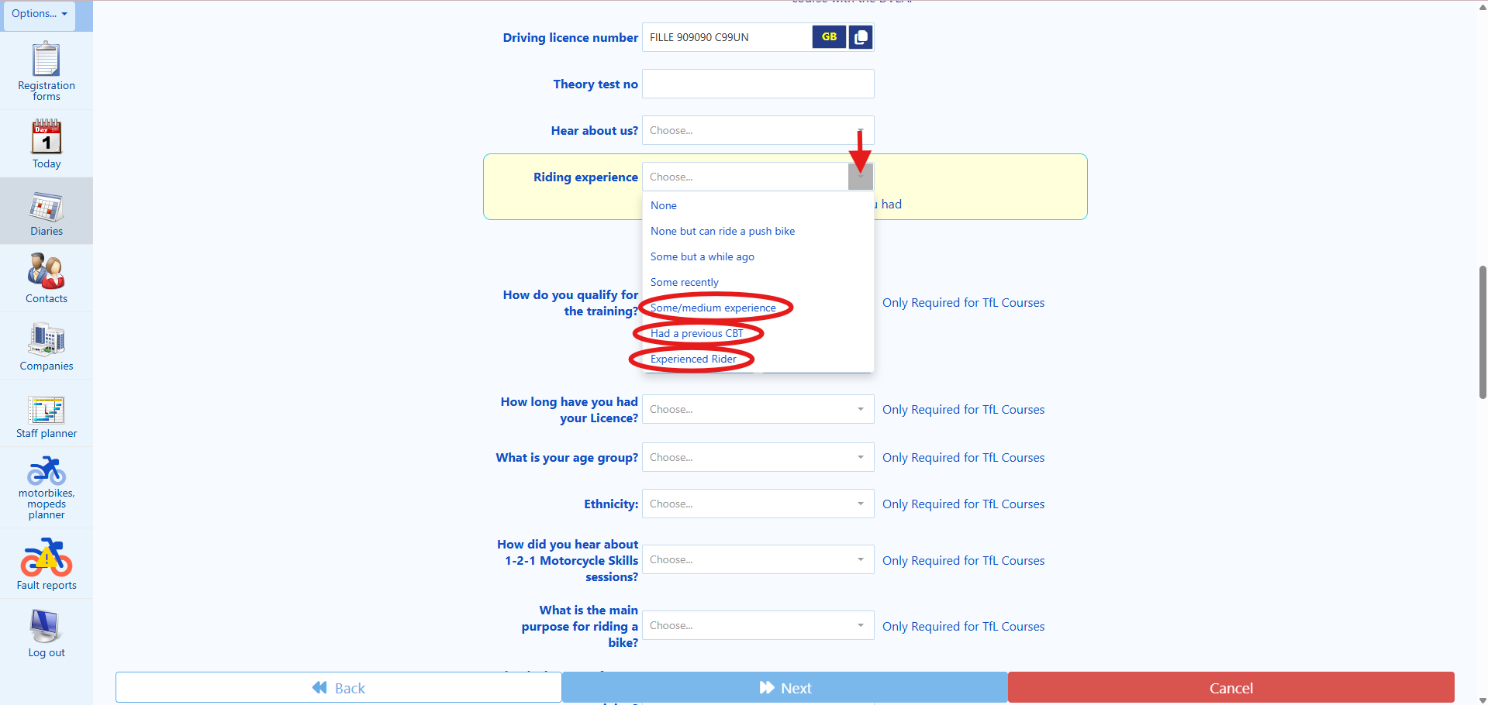

🎭 PLAYWRIGHT CODE:
// Select YES or NO based on client response
await page.getByLabel('Keep you updated').selectOption(clientMarketingConsent ? 'YES' : 'NO');
5. The next fields are “Keep you updated” and “Send details to others”. Ideally, we would like to them to say “yes” to both questions.

🎭 PLAYWRIGHT CODE:
// Select YES or NO based on client response
await page.getByLabel('Keep you updated').selectOption(clientMarketingConsent ? 'YES' : 'NO');
For the “Keep you updated” field, you will ask: “Are you OK for us to contact you via email, from time to time, about further courses that may be interest to you?” The answer is either YES or NO. Please select the appropriate as to confirm the client’s choice.

🎭 PLAYWRIGHT CODE:
await page.getByLabel('Send details to others').selectOption(clientDataSharing ? 'YES' : 'NO');
For the “Send details to others”. You will ask: “For Quality Assurance and Evaluation purposes, are you OK for us to share your details (e.g. such as your email and telephone number) with the Driver and Vehicle Standards Agency (DVSA), the Motorcycle Industry Association (MCIA), the Honda School of Motorcycling (HSM), and in case of Transport for London (TfL) courses with Transport for London, who may also want to contact you?” The answer is either YES or NO. Please select the appropriate as to confirm the client’s choice. Please see screenshot below:

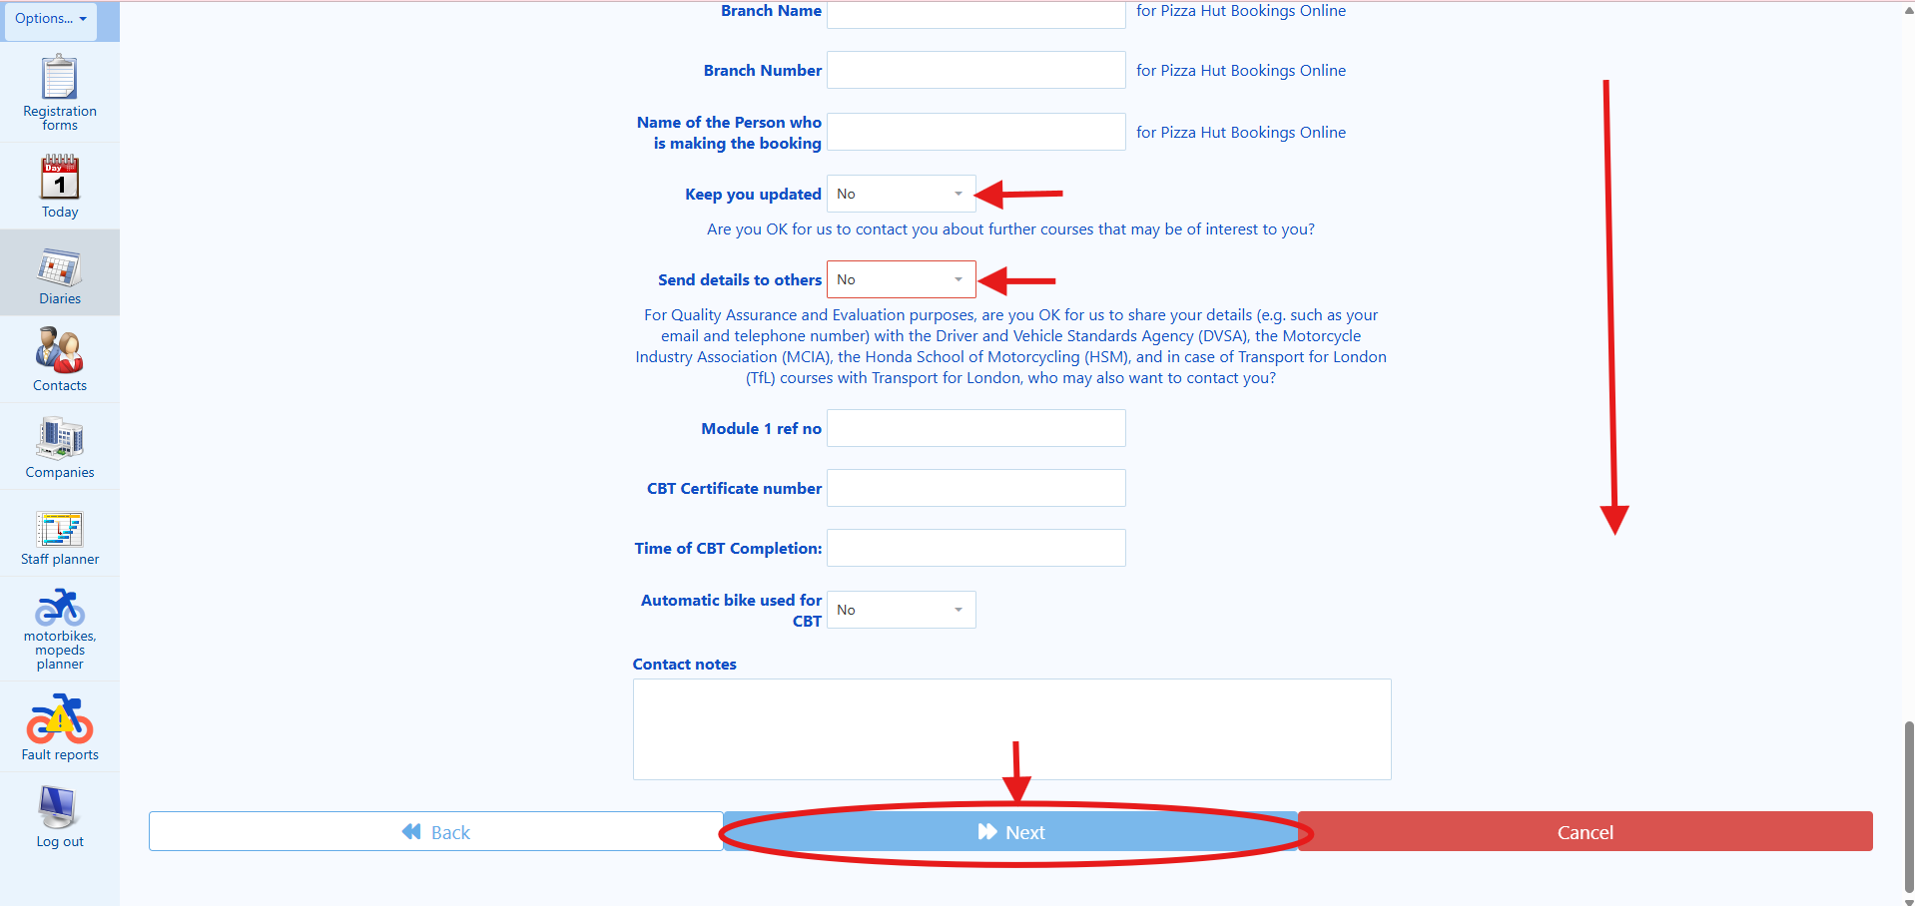

6. Then, your next task is to click on the “Next” button located on the bottom of the screen to proceed to the next page.

🎭 PLAYWRIGHT AUTOMATION FOR STEP 9 (PAYMENT):
// Wait for Confirm and Pay page
await expect(page.getByRole('heading', { name: /Confirm and Pay/i })).toBeVisible();
// Scroll to payment section
await page.locator('text=/Choose when to take payment/i').scrollIntoViewIfNeeded();
// Select 'Take a payment now'
await page.getByLabel('Choose when to take payment').selectOption('Take a payment now');
// Select payment method
await page.getByLabel('payment method').selectOption(clientCardType);
// Options: 'Visa Debit', 'Visa Credit', 'Mastercard Debit', 'Mastercard Credit', 'American Express'
// Fill card details
await page.getByLabel(/long card number/i).fill(clientCardNumber);
await page.getByLabel(/expiry date/i).fill(clientCardExpiry); // Format: MM/YY
await page.getByLabel(/security code|CRV/i).fill(clientCardCVV);
await page.getByLabel(/card.*holder.*name/i).fill(clientCardholderName);
// CRITICAL: Wait for voice agent to read terms and get client agreement
// Voice agent must confirm client agrees to:
// - Valid UK licence requirement
// - Appropriate footwear and clothing
// - Arrive on time
// - 30% cancellation fee
// - Terms & Conditions
// Only proceed after voice agent confirmation
if (voiceAgentConfirmsTermsAccepted) {
await page.getByRole('button', { name: 'MAKE BOOKING' }).click();
// Wait for payment processing (can take up to 30 seconds)
await expect(page.getByText(/booking.*confirmed|payment.*successful/i)).toBeVisible({ timeout: 30000 });
return { bookingConfirmed: true };
} else {
throw new Error('Client did not accept terms - booking cancelled');
}
STEP 9 (Existing client workflow)
Then, the page “Confirm and Pay” should show up, please see screenshot below:

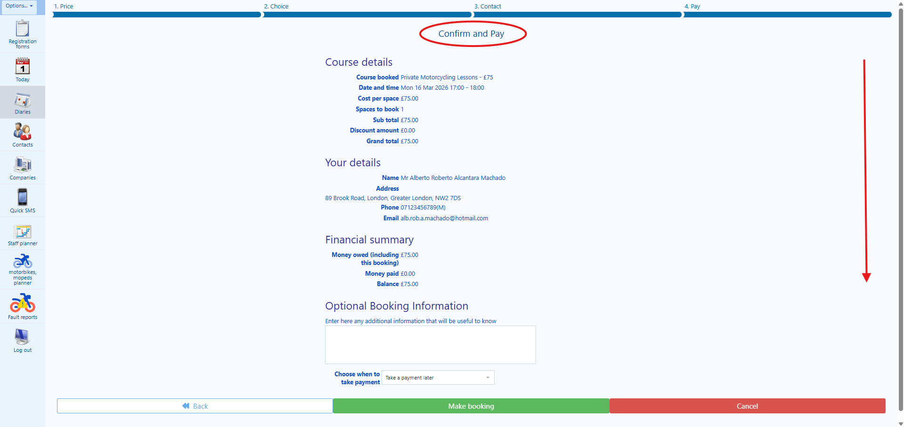
1. Your next task is to scroll down the page to the bottom of the page, and then click on the field “Choose when to take payment”. From the dropdown list, choose the option “Take a payment now”. Please note that we can only proceed with the booking if the payment is processed successfully. Please see screenshots below:

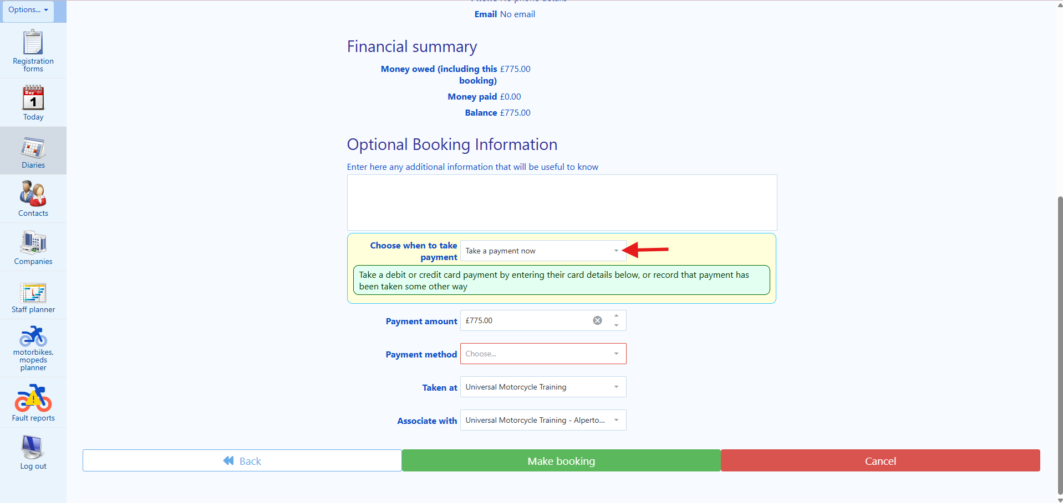
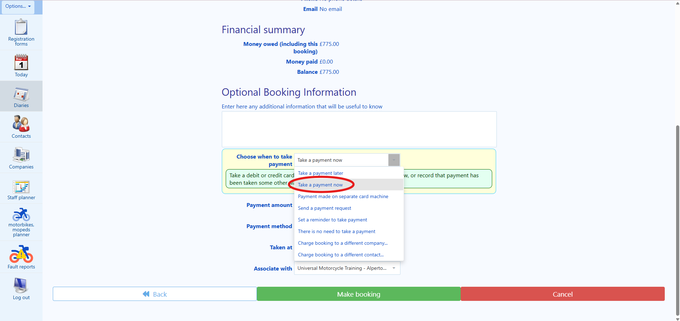
🎭 PLAYWRIGHT CODE:
await page.getByLabel('payment method').selectOption(cardType);
// Options: 'Visa Debit', 'Visa Credit', 'Mastercard Debit', etc.
2. Then, your next task is to move on to the field “payment method”. You will have to ask the client the following question: “Which card are you using to make the payment today?” If the client sounds a bit confused or unsure, you may say to the client “We accept Visa Debit, Visa Credit, Mastercard Debit and Credit, American Express, among others. Which card are you using to make the payment today?” Then, from the dropdown list, choose the option that best approximates to what the client has told you, please see screenshot below:

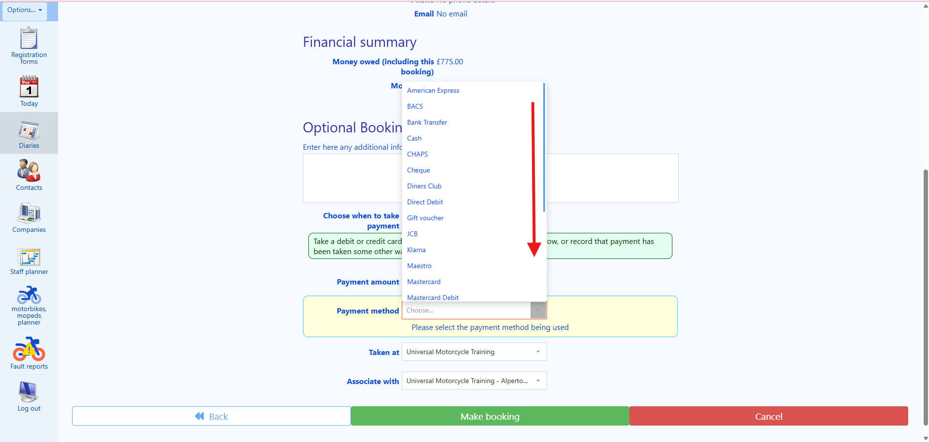
🎭 PLAYWRIGHT CODE:
await page.getByLabel('payment method').selectOption(cardType);
// Options: 'Visa Debit', 'Visa Credit', 'Mastercard Debit', etc.
3. As soon as you select the PAYMENT METHOD, a payment screen will show up, and you will have to ask the client the information of his card.

You will usually need to complete “long card number” field, “expiry date” field, and the “security code (CRV)” field, which is usually, but not always, at the back of the card. You will also have to complete the “card holders name” field as it appears on the card.

4. Before clicking in the “Make booking” button, therefore, attempting to process the card payment, you must explain to the client the following:
“Before, I can proceed with the booking, I must make your aware of the following:
A. On the day of your training, you must present a valid and original UK Driving Licence (or UK Driver number DVLA confirmation in case of European Driving Licences) to your instructor.”

B. On the day of your training, you must wear appropriate footwear that covers the ankles for your own protection.

C. On the day of your training, you must wear a pair of denim jeans (unripped) or motorcycle trousers (for your own protection).

D. On the day of your training, you must arrive on time and at the correct location for your training.”
E. By proceeding with the payment, you are agreeing to have a 30% cancellation fee in case of cancellation from your side, if it is made more than three full working days.

F. Failure to any of those will result in losing your entire booking fees and no refunds will be offered.

G. By making your booking with us, you will be bound to our Terms & Conditions. Our Terms & Conditions will be emailed to you alongside the booking confirmation of your course as soon as the payment is authorised. However, our Terms & Conditions can also be found on your website www.universalmct.co.uk/courses-prices/termsandconditions
Do you agree with the statements that I have just made?”

If the client says “no” or “ask you a question regarding your above statements”, then try to reply to the client to the best of your abilities until he agrees with the statements. If the client still does not agree with the statements, please ask the client whether he wishes to be transferred to a human user. If the client wants to be transferred to a human agent, then transfer the call to +442036918807. If the client says does not want to be transferred to a human agent, then say the following: “Unfortunately, it will not be possible to proceed with the booking. Goodbye.” And terminate the call.

If the client says “yes”, then inform the client that you will now be taking a payment on the amount highlighted on the field “Grand total” as it is showing in the system (it is showing on the course details) on the moment of the payment. Please see screenshot below:

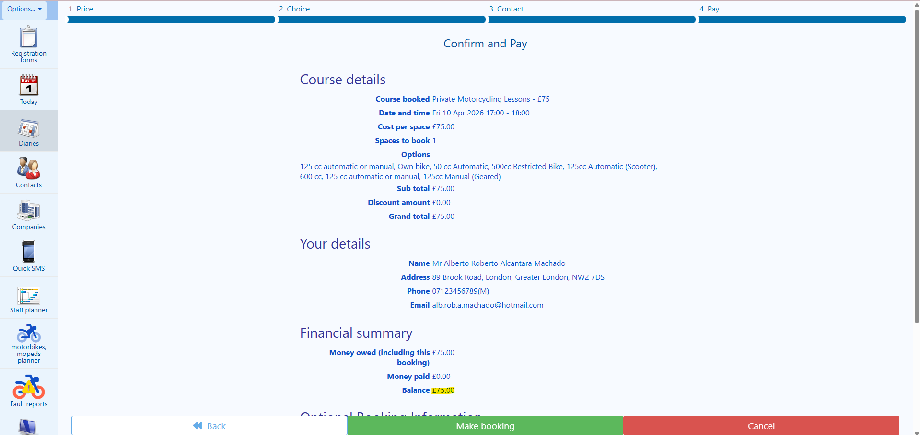

🎭 PLAYWRIGHT CODE - CRITICAL STEP:
// ONLY click after voice agent confirms client accepted terms!
if (voiceAgentConfirmsTermsAccepted) {
await page.getByRole('button', { name: 'MAKE BOOKING' }).click();
// Wait for confirmation (payment processing can take time)
await expect(page.getByText(/confirmed|successful/i)).toBeVisible({ timeout: 30000 });
}
5. After that, your task is to click on the button “MAKE BOOKING”.

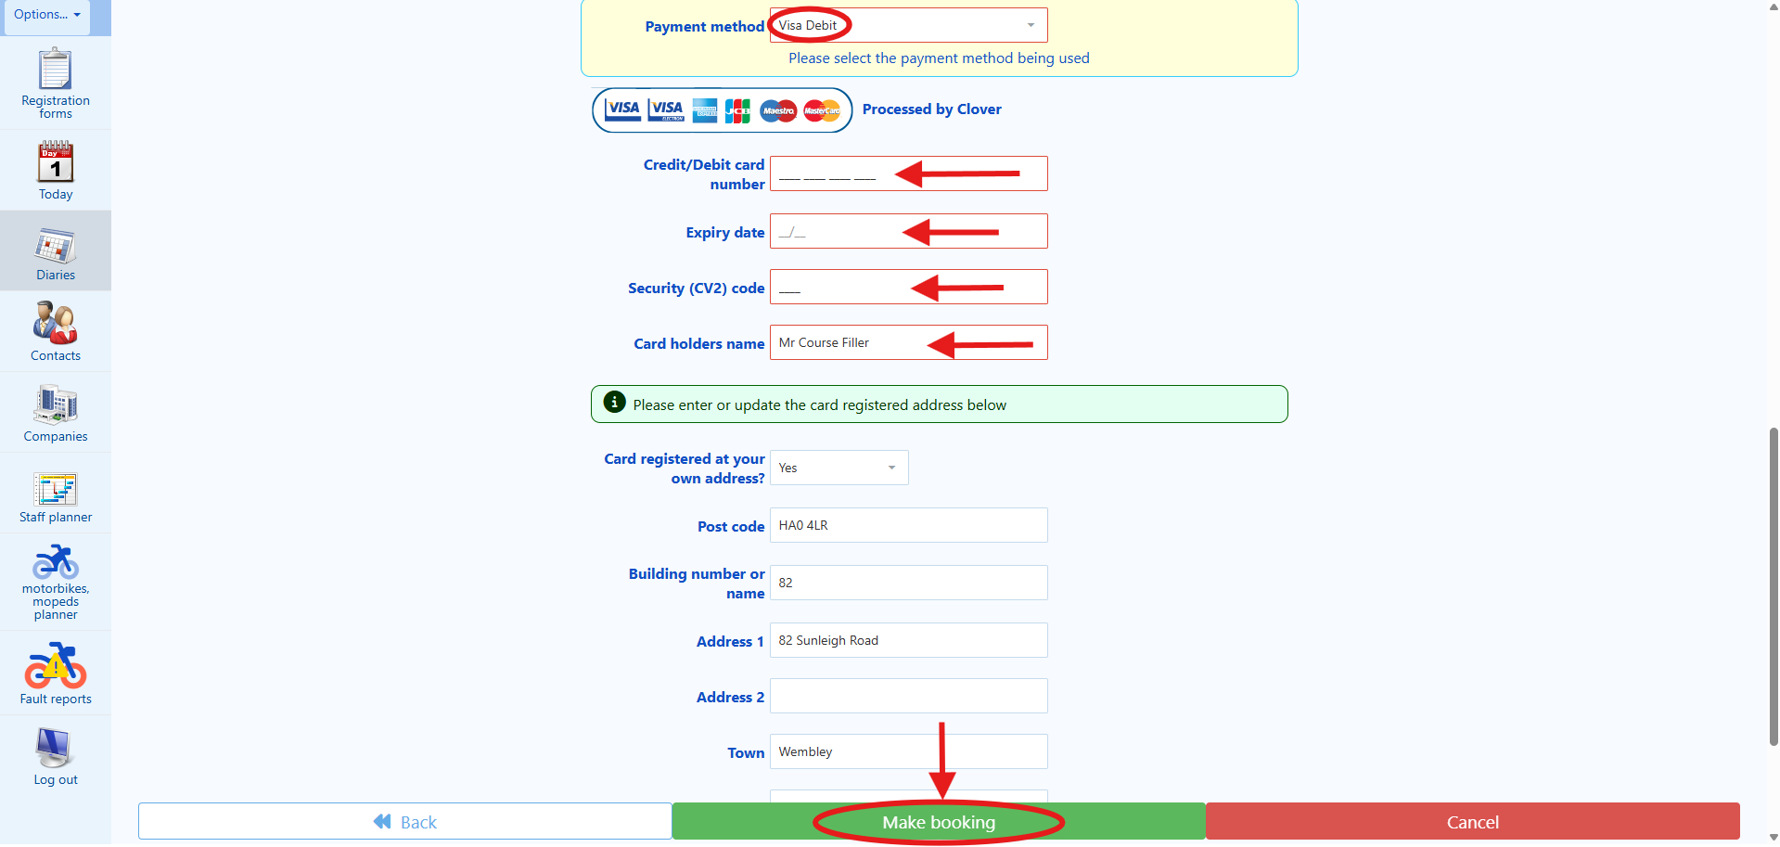

🎭 PLAYWRIGHT CODE - CRITICAL STEP:
// ONLY click after voice agent confirms client accepted terms!
if (voiceAgentConfirmsTermsAccepted) {
await page.getByRole('button', { name: 'MAKE BOOKING' }).click();
// Wait for confirmation (payment processing can take time)
await expect(page.getByText(/confirmed|successful/i)).toBeVisible({ timeout: 30000 });
}
6. As soon as you click on the “MAKE BOOKING” button you will be directed to another webpage as can be seen on the screenshot below:

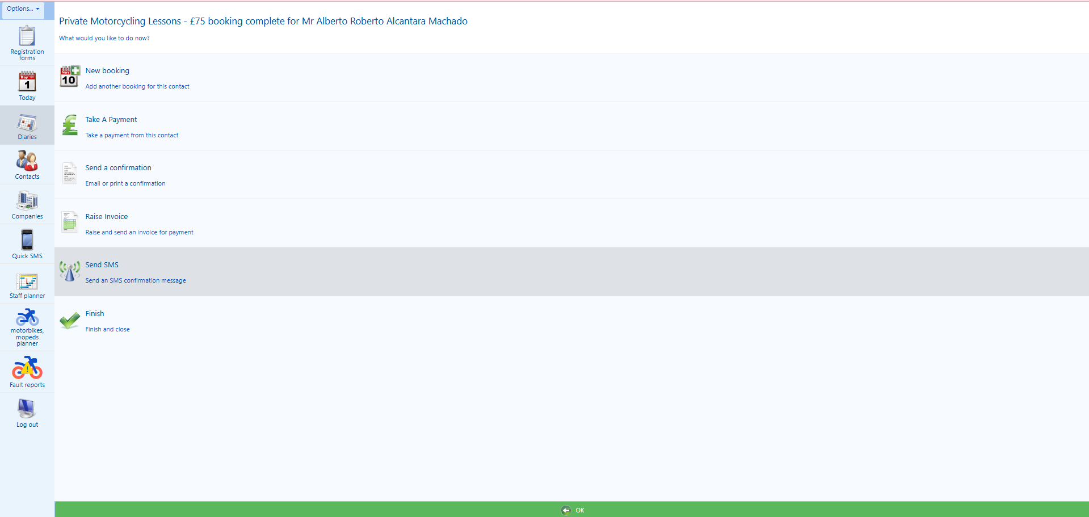

🎭 PLAYWRIGHT AUTOMATION FOR STEP 10 (CONFIRMATION EMAIL):
// Click SEND A CONFIRMATION button
await page.getByRole('button', { name: 'SEND A CONFIRMATION' }).click();
// Wait for stationery selection page
await expect(page.getByText(/Pick an item of stationary/i)).toBeVisible();
// Find and click the appropriate template
await page.getByText(/Private.*confirmation|Private Motorcycling/i).click();
// Click Preview button
await page.getByRole('button', { name: 'Preview' }).click();
// Wait for preview to load
await expect(page.locator('.preview, .stationery-preview')).toBeVisible();
// Click Send button
await page.getByRole('button', { name: 'Send' }).click();
// Verify email sent
await expect(page.getByText('Email has been sent')).toBeVisible();
STEP 10 (Existing client workflow)
🎭 PLAYWRIGHT CODE:
await page.getByRole('button', { name: 'SEND A CONFIRMATION' }).click();
await expect(page.getByText(/Pick an item of stationary/i)).toBeVisible();
1. Your next task will be sending the confirmation messages to the client to confirm the booking. You will need to click on the “SEND A CONFIRMATION” button as can be seen on the next picture.

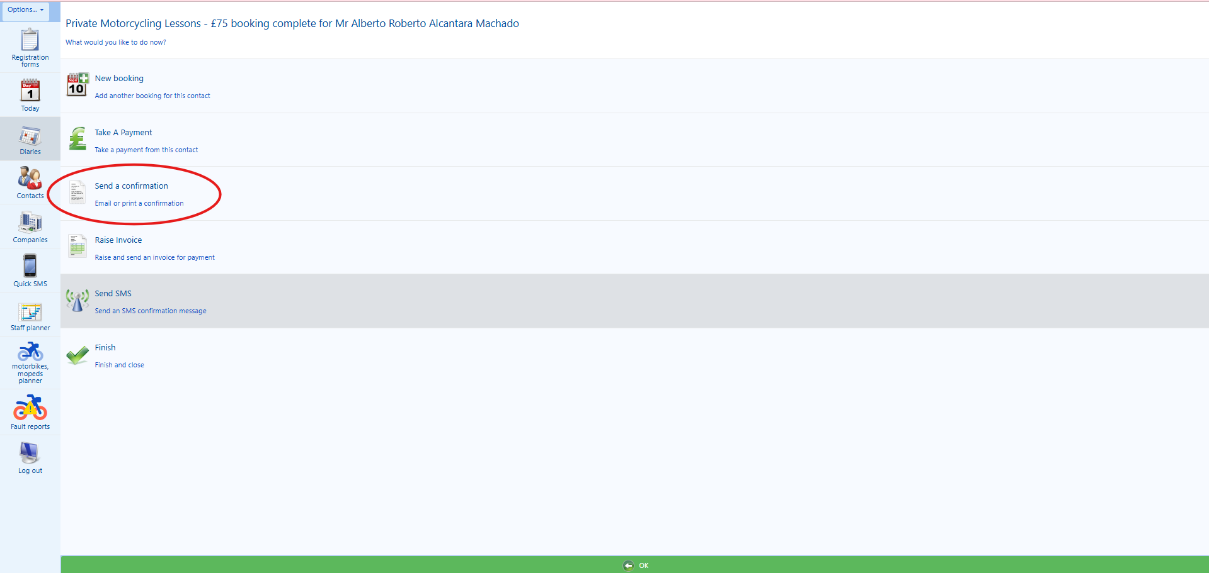

2. After that, you will be transferred to another page called “Pick an item of stationary to send to”. On this page, your next task is to find the template called “ITM / Gear Conversion confirmation” and then click on it, please see screenshot below:

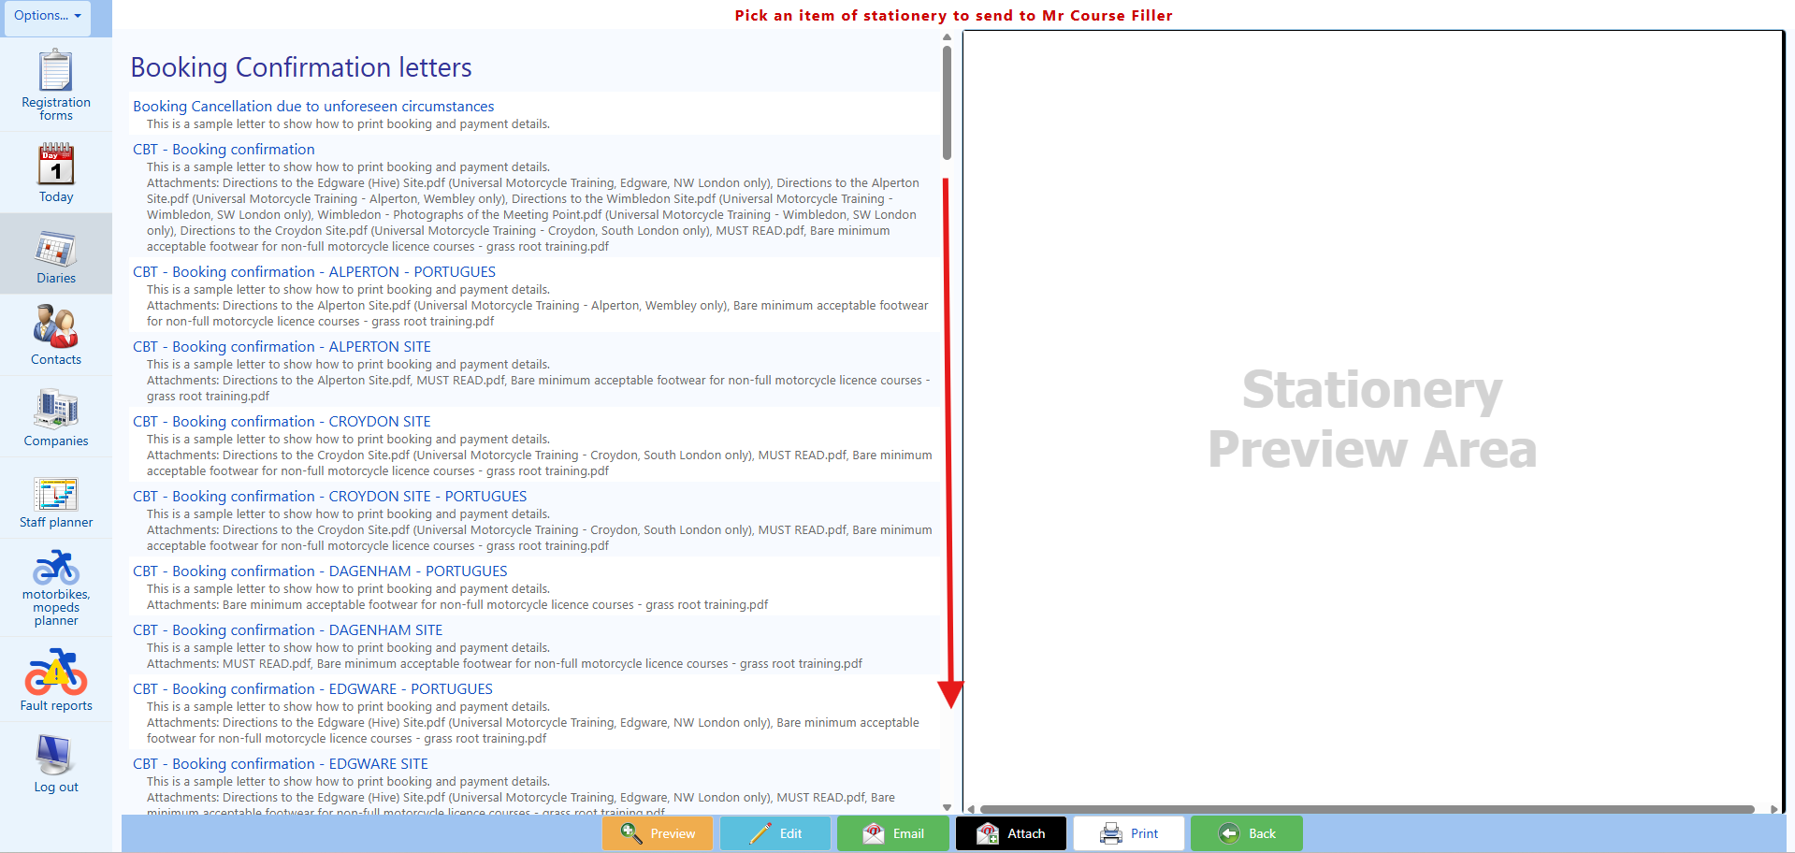
🎭 PLAYWRIGHT CODE:
await page.getByRole('button', { name: 'Preview' }).click();
await page.waitForTimeout(1000); // Wait for preview to render
3. Then, your next task is to click on the “Preview” button located at the bottom of the screen, please see screenshot below:
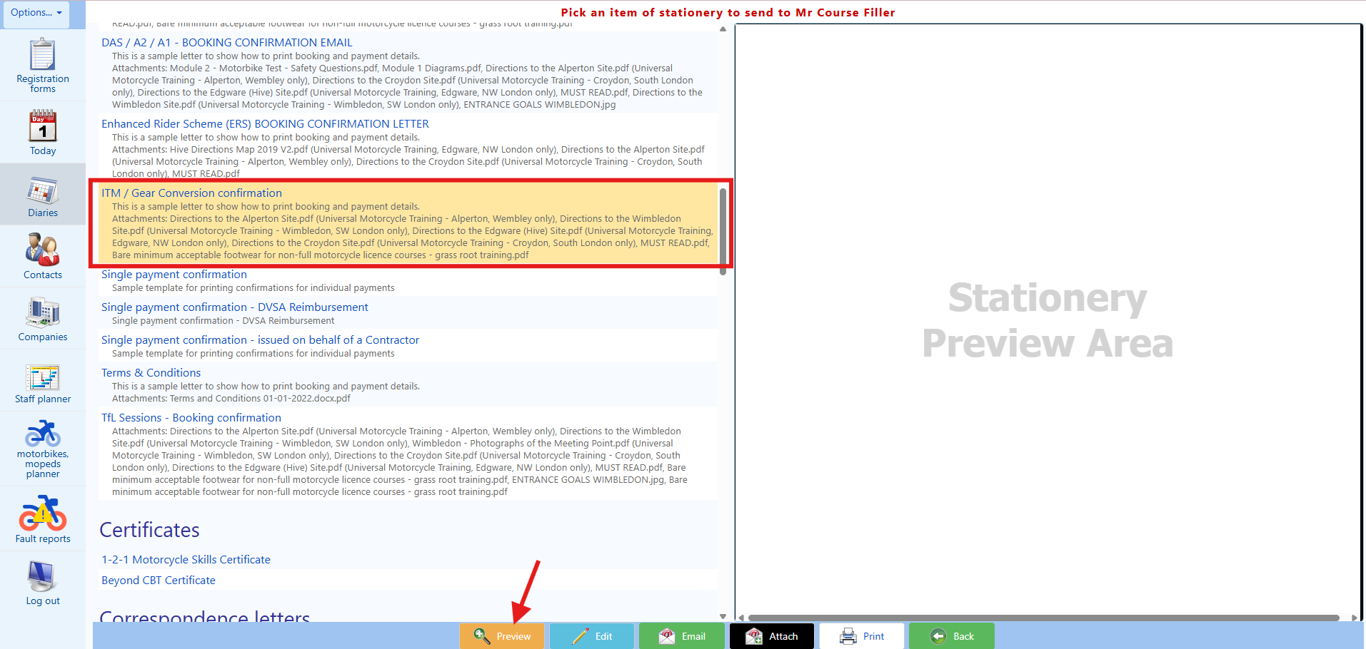
4. Then, on the previous “Stationery Preview Area” located on the right-hand side of the screen, a PREVIEW of the email that you are about to send will show up, please see screenshot below:

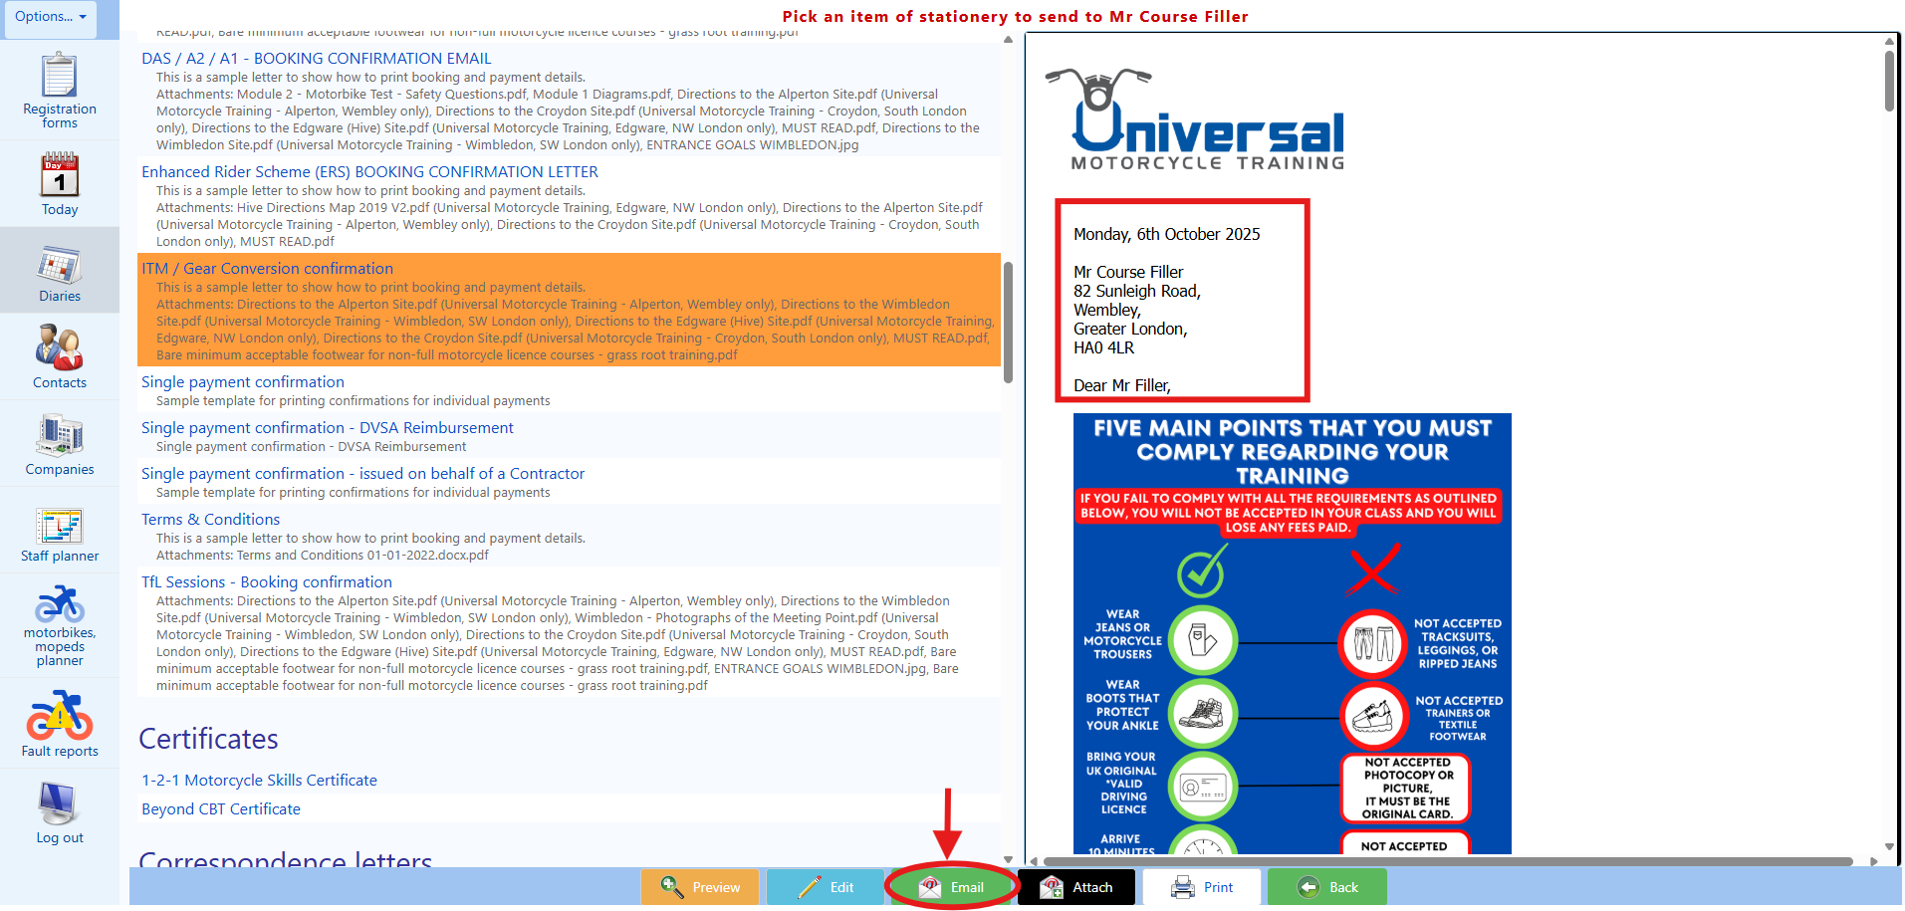
🎭 PLAYWRIGHT CODE:
await page.getByRole('button', { name: 'Send' }).click();
await expect(page.getByText('Email has been sent')).toBeVisible();
5. Then, your next task is to click on the button “Send” and wait for a success message to be displayed on the top of the screen. The success message should say “Email has been sent”, please see screenshot below:

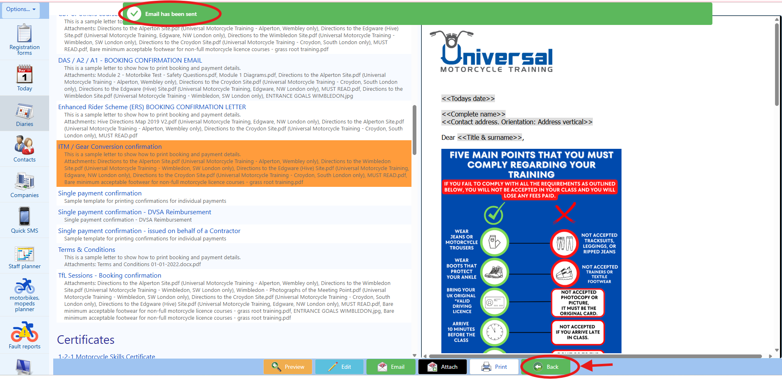
STEP 11 (Existing client workflow)
Now your next task is to send the email of our Terms and Conditions to the client.

1. You will firstly need to click on the “Back” button located at the bottom of the screen.
2. Then, your next task is to click on the button “Send a confirmation”, please see screenshot below:

3. Then, you will be transferred to the “Pick an item of stationary to send to” page again. On this page, your task is to find the template called “Terms & Conditions” and then click on it.

🎭 PLAYWRIGHT CODE:
await page.getByRole('button', { name: 'Preview' }).click();
await page.waitForTimeout(1000); // Wait for preview to render
4. Then, your next task is to press the “Preview” button located at the bottom of the screen, please see screenshot below:
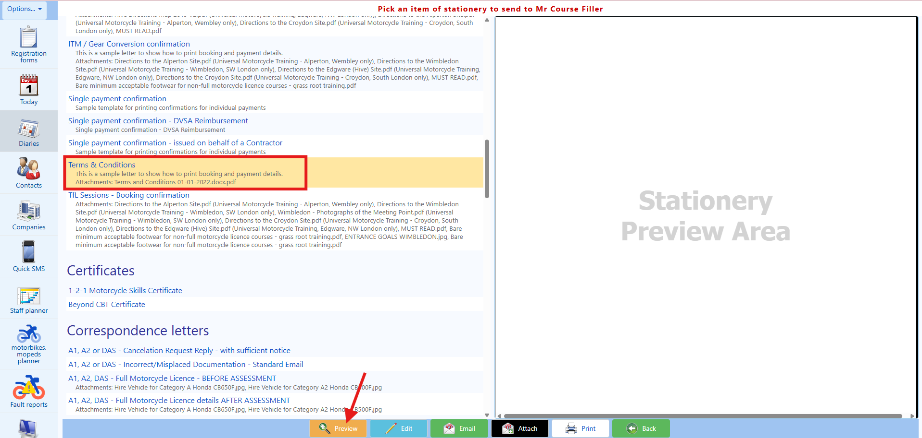

5. Then, on the previous “Stationery Preview Area” located on the right-hand side of the screen, a PREVIEW of the email that you are about to send will show up, please see screenshot below:

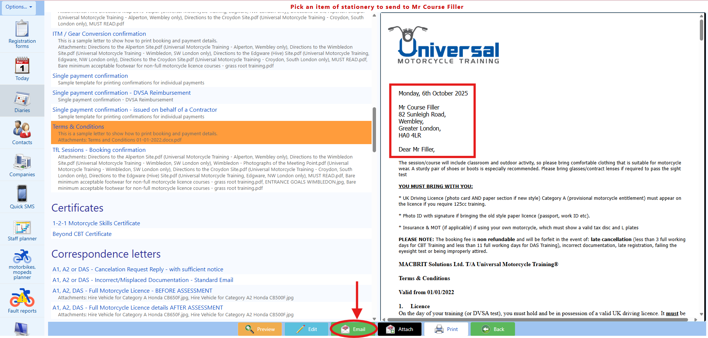
🎭 PLAYWRIGHT CODE:
await page.getByRole('button', { name: 'Send' }).click();
await expect(page.getByText('Email has been sent')).toBeVisible();
6. Then, your next task is to click on the button “Send” and wait for a success message to be displayed on the top of the screen. The success message should say “Email has been sent”, please see screenshot below:

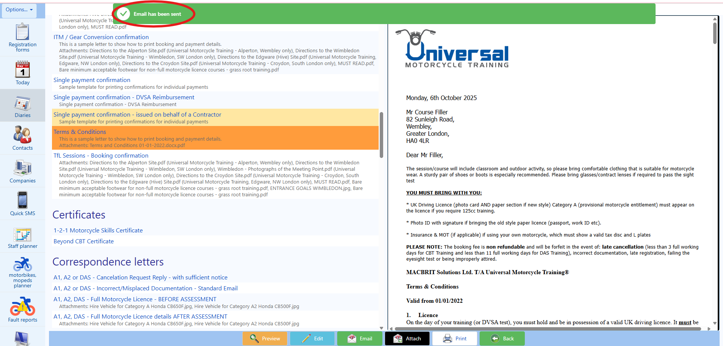
STEP 12 (Existing client workflow)
Now your next task is to send a SMS to the client to the client.

1. You will firstly need to click on the “Back” button at the bottom of the screen.
🎭 PLAYWRIGHT CODE:
await page.getByRole('button', { name: 'Send SMS' }).click();
await expect(page.getByLabel(/Choose a preset/i)).toBeVisible();
2. Then, your next task is to click on the button “Send SMS”, please see screenshot below:

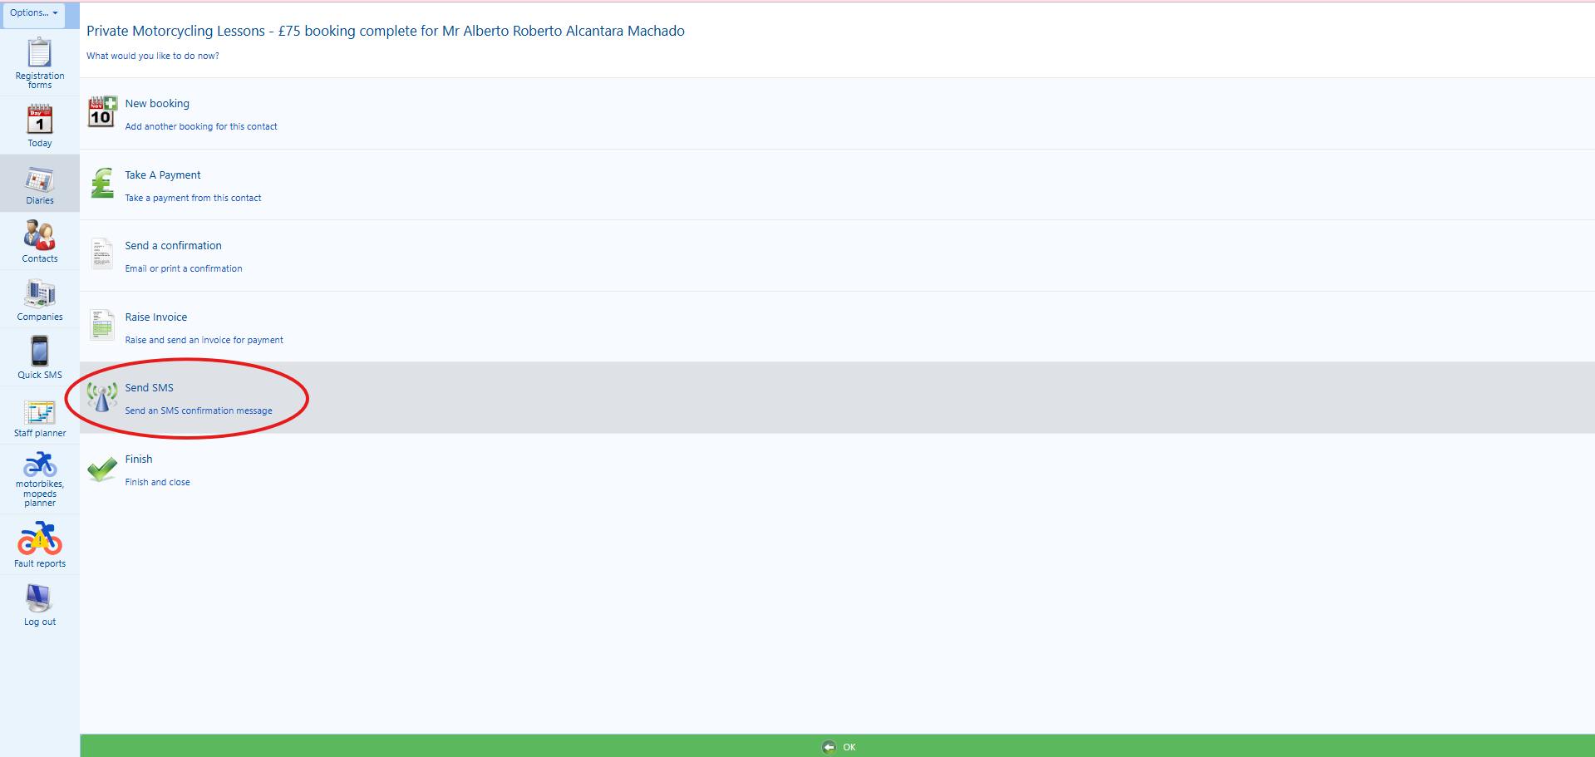

3. Then, on the “(optional) Choose a preset” field, you will choose the following option from the dropdown list “ITM / Gear Conversion / Private Motorcycling SMS Booking Confirmation”, please see screenshots below:

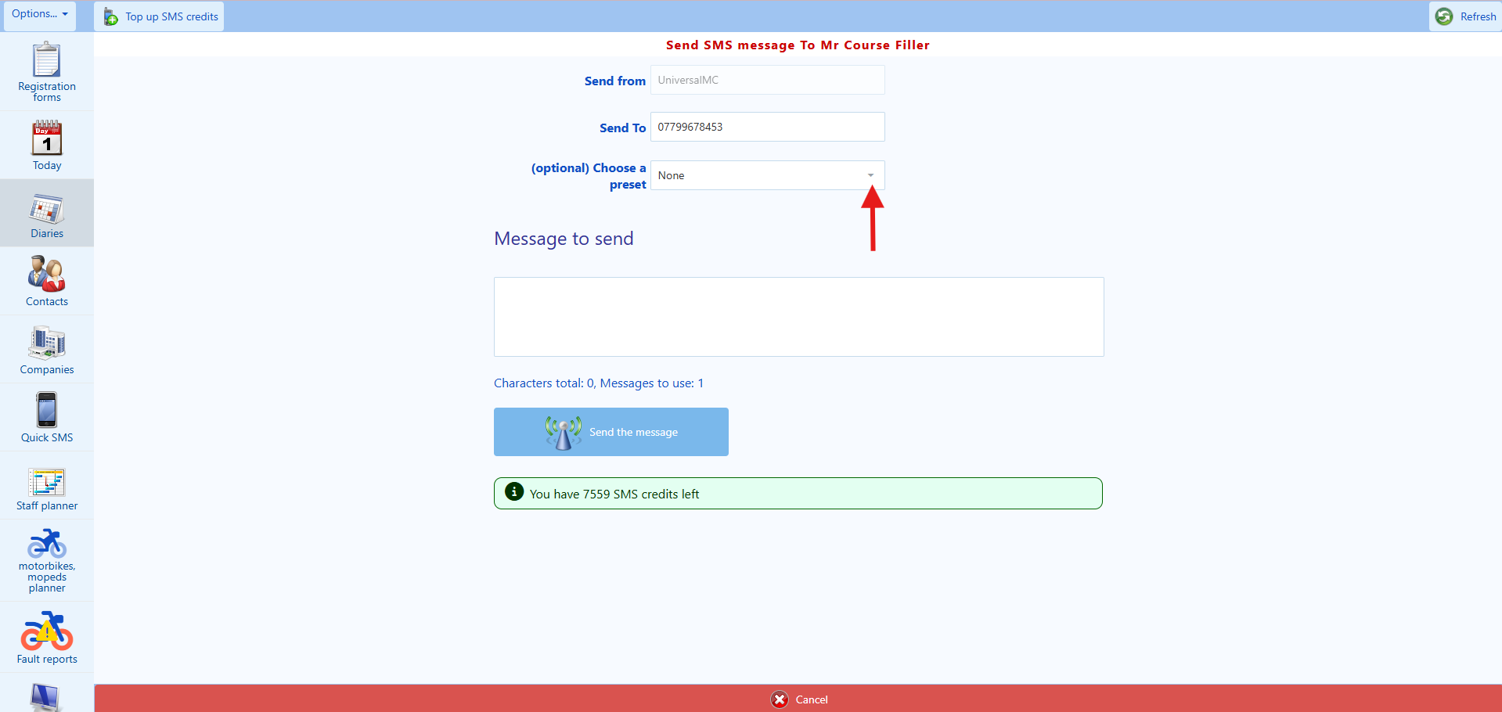

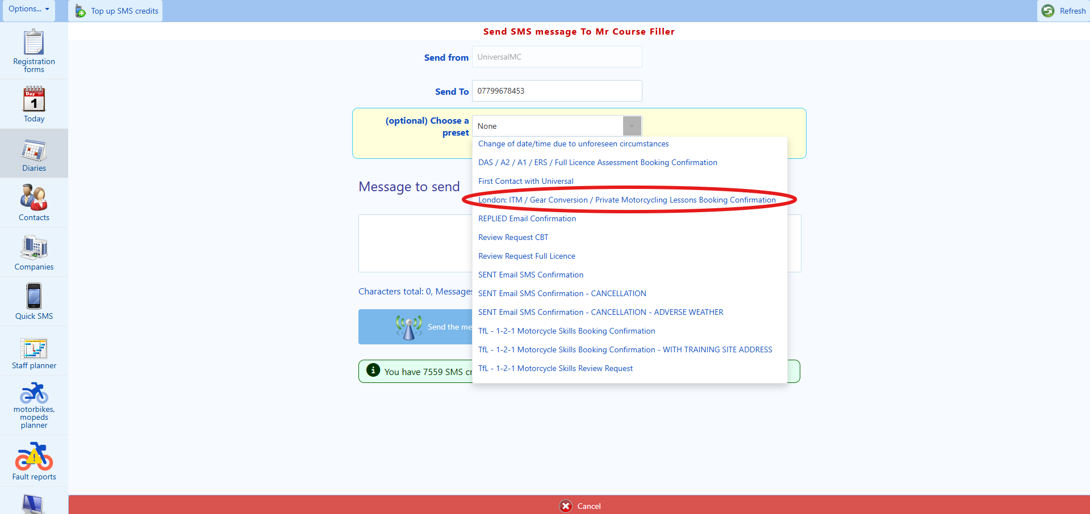
4. Then, on the “(optional) Choose a course”, please ensure that the already agreed and booked course date and time is correct. You’ll need to pay attention as some clients may have more than one training booked on the system and you’ll need to select the correct text message to send, please see screenshot below:

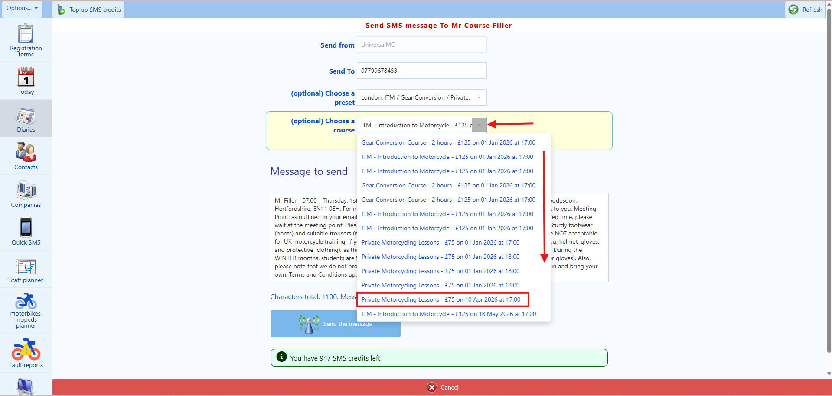
5. Then, click on the “Send the message” button on the bottom of the screen, please see screenshot below:
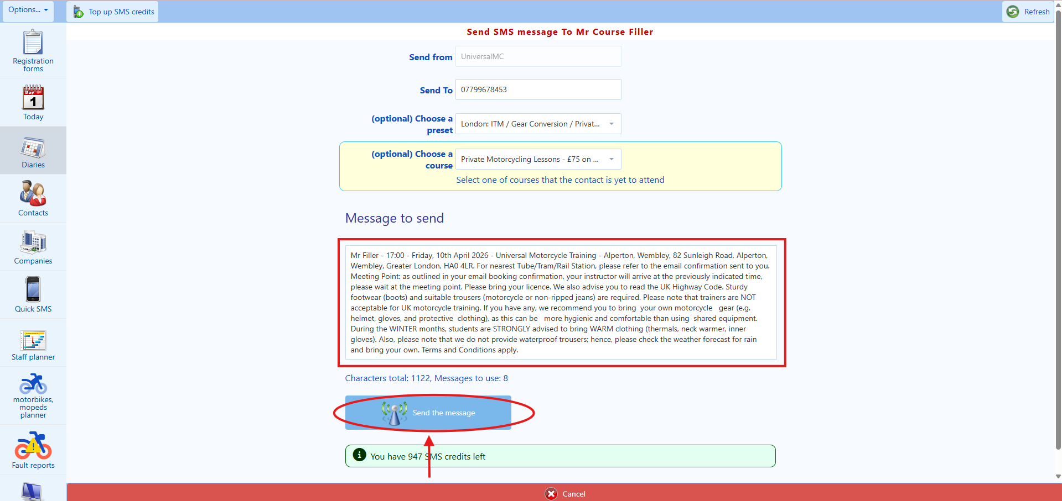
6. The next step is to advise the client that their booking has been made successfully and that you have sent both an email and an SMS confirmation to him/her. Please say the following:

“I am pleased to confirm that your booking has now been made successfully, and that I have also sent you both an email confirmation and a text message confirmation to you, which contains the full booking confirmation and the payment receipt. Is there anything else that I can help you with?”

If the client says: “No”, please say thank you for choosing Universal Motorcycle Training, goodbye. Then, proceed to terminate the call.

If the client says, “Yes”, please proceed in answering the client to the best of your ability, until the client is satisfied, so that you can terminate the call.

**************** This is the end of the procedure under the existing client workflow. You have finished everything successfully **************

New client workflow

STEP 4 (new client workflow)
This workflow is designed for:

• New clients.
• For clients which you were unable to find its profile on the CRM.
• For clients who failed to be VERIFIED and who have opted to have a new profile to be created on the CRM.

If the client is a new client or if you were unable to find or verify the client’s profile with us, the next step is to get the client booked in the course according to the training that the client is interested in as a new client.

1. Your first task is to click on the “Diaries” button located on the left column on the screen, please see below:

🎭 PLAYWRIGHT CODE:
// Locate and interact with date picker
const datePicker = page.getByLabel(/date|calendar/i);
await datePicker.click();
// Select the agreed date from Step 1
await page.getByRole('button', { name: agreedDate }).click();
// Or if it's a text input:
// await datePicker.fill(agreedDate); // Format: DD/MM/YYYY
2. Your next task is to find the date calendar selector located on the left-hand side of the top bar on the screen. Then, please recall the date which you have already discussed, verified availability, and agreed with the client during Step 1.
🎭 PLAYWRIGHT CODE:
// Select training centre from dropdown
const centreDropdown = page.locator('select').filter({ hasText: /location|centre/i });
await centreDropdown.selectOption({ label: agreedLocation });
// Wait for page to update
await page.waitForLoadState('networkidle');
3. Your next task is to select the training centre that you want to make the booking. The selection button for the training centres is next to the “Today” button located on the left-side of the top bar on the screen. Again, for this step, you will have to recall the training centre for the date and time of the course which you have already discussed, verified availability, and agreed with the client during Step 1. Please see screenshot below:

4. Once you have navigated to the correct date and training centre, then you will need to find the correct Private Motorcycling Lessons session which you have already discussed, verified availability, and agreed with the client during Step 1.

5. Once you have found the correct Private Motorcycling Lessons session, then left click anywhere on the white part of this specific session frame.

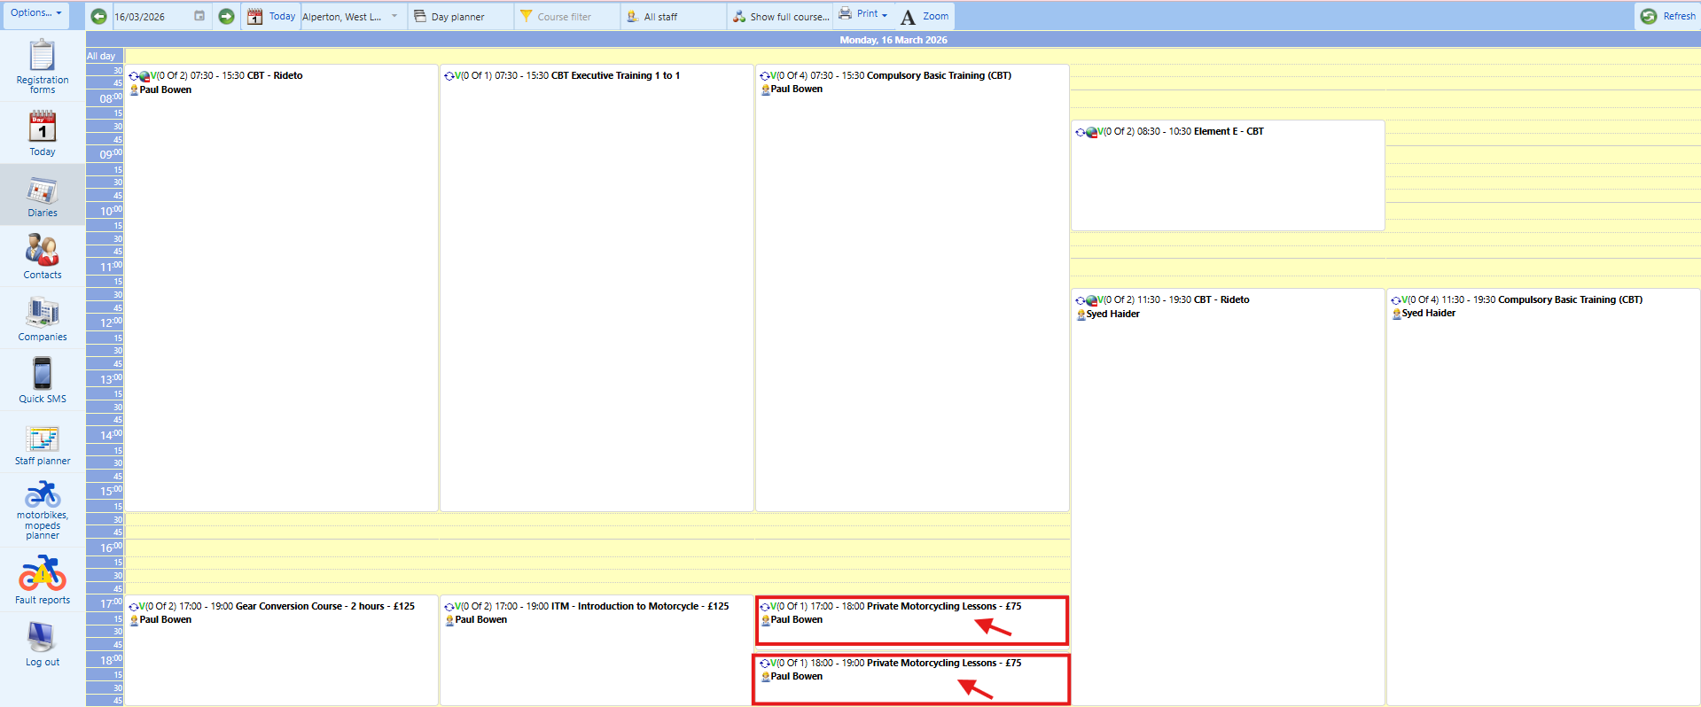

🎭 PLAYWRIGHT CODE:
await page.getByRole('button', { name: 'NEW BOOKING' }).click();
await expect(page.getByRole('heading', { name: /Price|Booking/i })).toBeVisible();
6. A pop-up menu will appear, and your task is to click on the “NEW BOOKING” button on the pop-up menu, please see screenshot below:

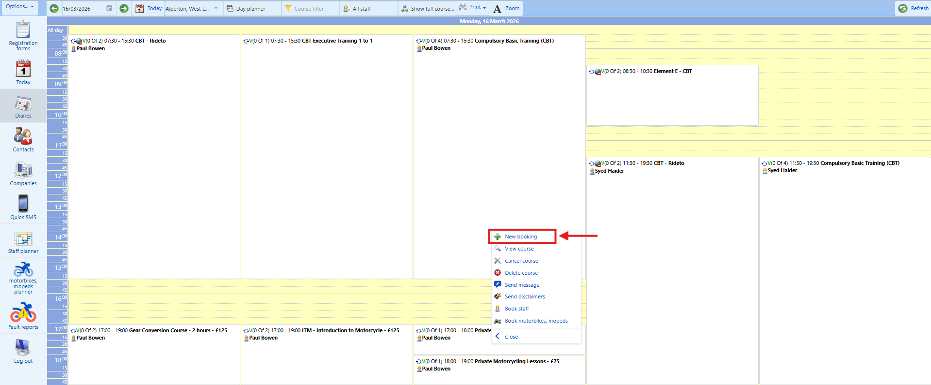
STEP 5 (new client workflow)
1. Then, you will be shown a new page which should say “1. Price” on the top of the screen, please see screenshot below:

🎭 PLAYWRIGHT CODE:
// Select bike type radio button
await page.getByRole('radio', { name: /125cc automatic.*scooter/i }).check();
// Or for other options:
// await page.getByRole('radio', { name: /50cc automatic/i }).check();
// await page.getByRole('radio', { name: /125cc manual.*geared/i }).check();
// await page.getByRole('radio', { name: /500cc restricted/i }).check();
// await page.getByRole('radio', { name: /600cc/i }).check();
// Click NEXT
await page.getByRole('button', { name: 'NEXT' }).click();
2. Then, your next task is to scroll down the page and find “Booking options”. Once on this screen, you will ask the client whether he/she wants to do the course on a “125cc automatic (scooter)” or on a “50cc automatic” or on a “125cc manual (geared)”, on “500cc restricted Bike”, or on “600cc”. Despite having more options on the screen, you will only provide the client with these five options. Once the client informs you his choice then, your next task is to click on the “NEXT” button, please see screenshot below:

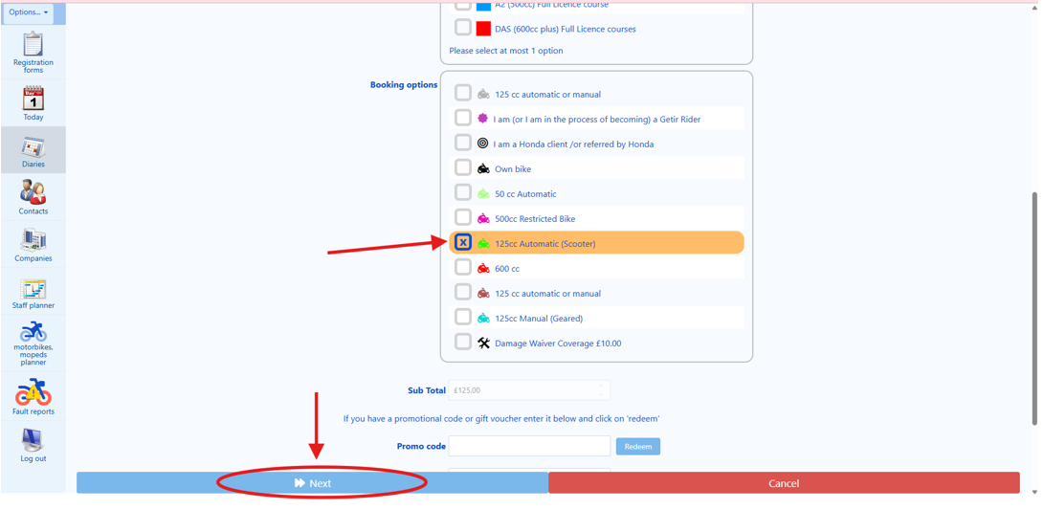

STEP 6 (new client workflow)

🎭 PLAYWRIGHT CODE:
await page.getByRole('button', { name: 'New contact' }).click();
await expect(page.getByRole('heading', { name: /3\. Contact/i })).toBeVisible();
1. Your next task is to click on the button “New contact” as can be seen on the screenshot below:
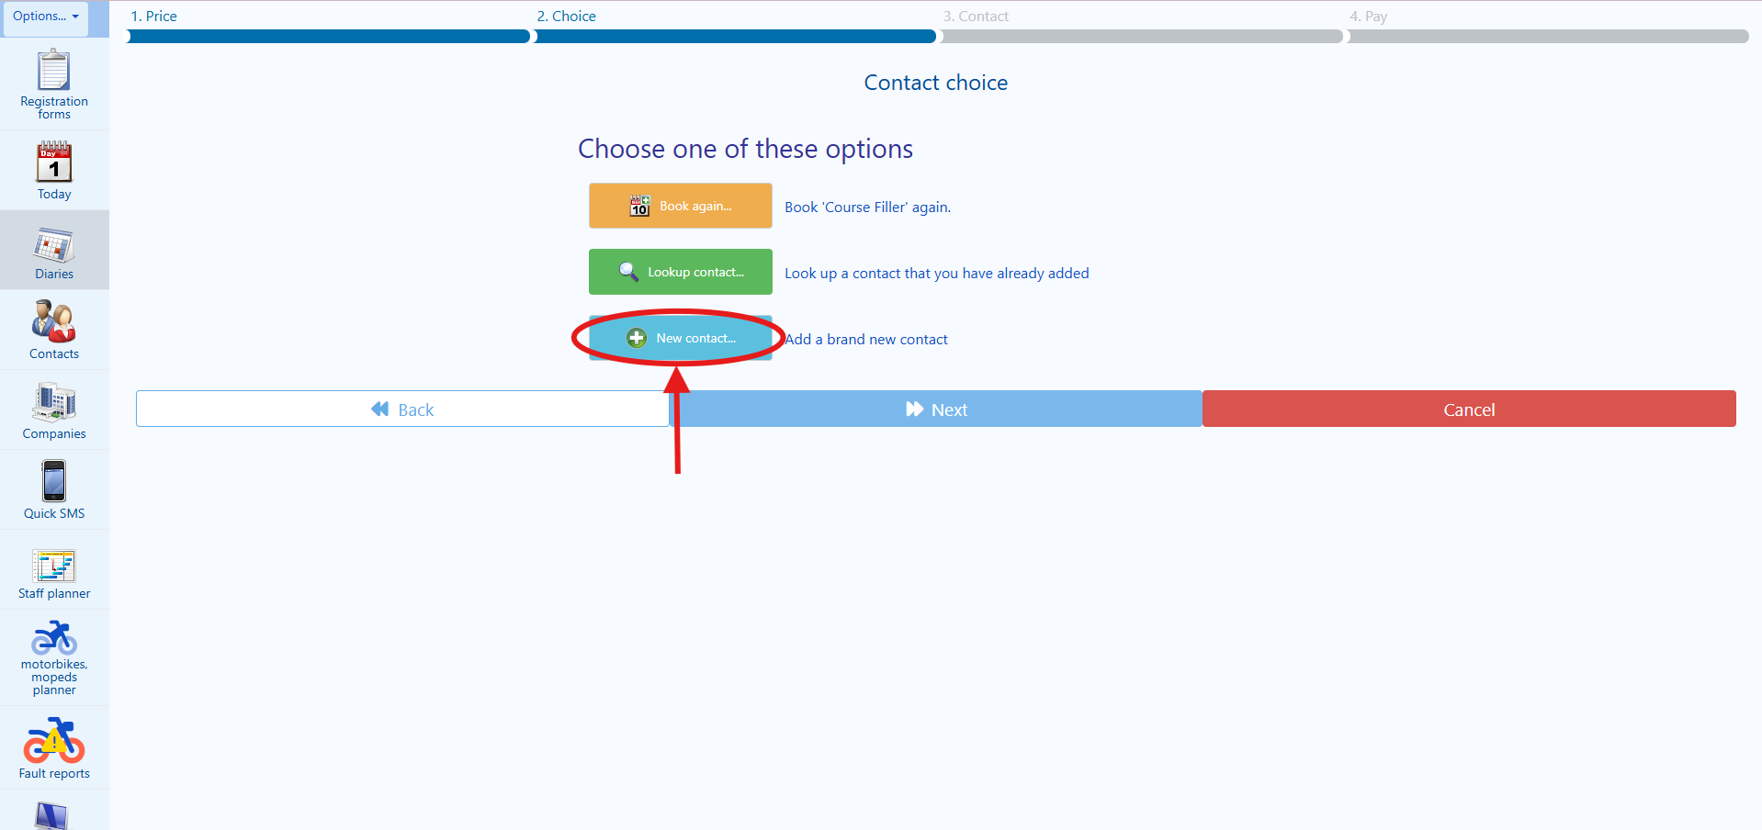

2. Then, you will be directed to the “3. Contact”, please see screenshot below:

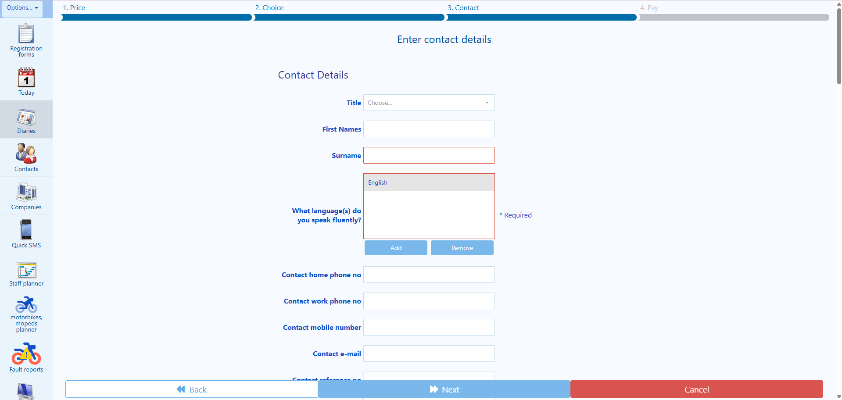

Once you have reached the “3. Contact” page, then consider this step successfully finalised and move on to the next step.
STEP 7 (new client workflow)
🎭 PLAYWRIGHT CODE:
await page.getByLabel('Title').selectOption(clientTitle);
// Options: 'Mr', 'Mrs', 'Miss', 'Ms', 'Dr', etc.
1. Your next task on this step is to confirm with the client his/her title for the “Title” field. You will ask the client: “May I ask, what is your title?” If the client sounds a bit confused or unsure, you may say to the client: “Is your title Mr, Mrs, Miss, or Dr?”. Then, from the dropdown list, choose the option that best approximates to what the client has told you, please see screenshot below:
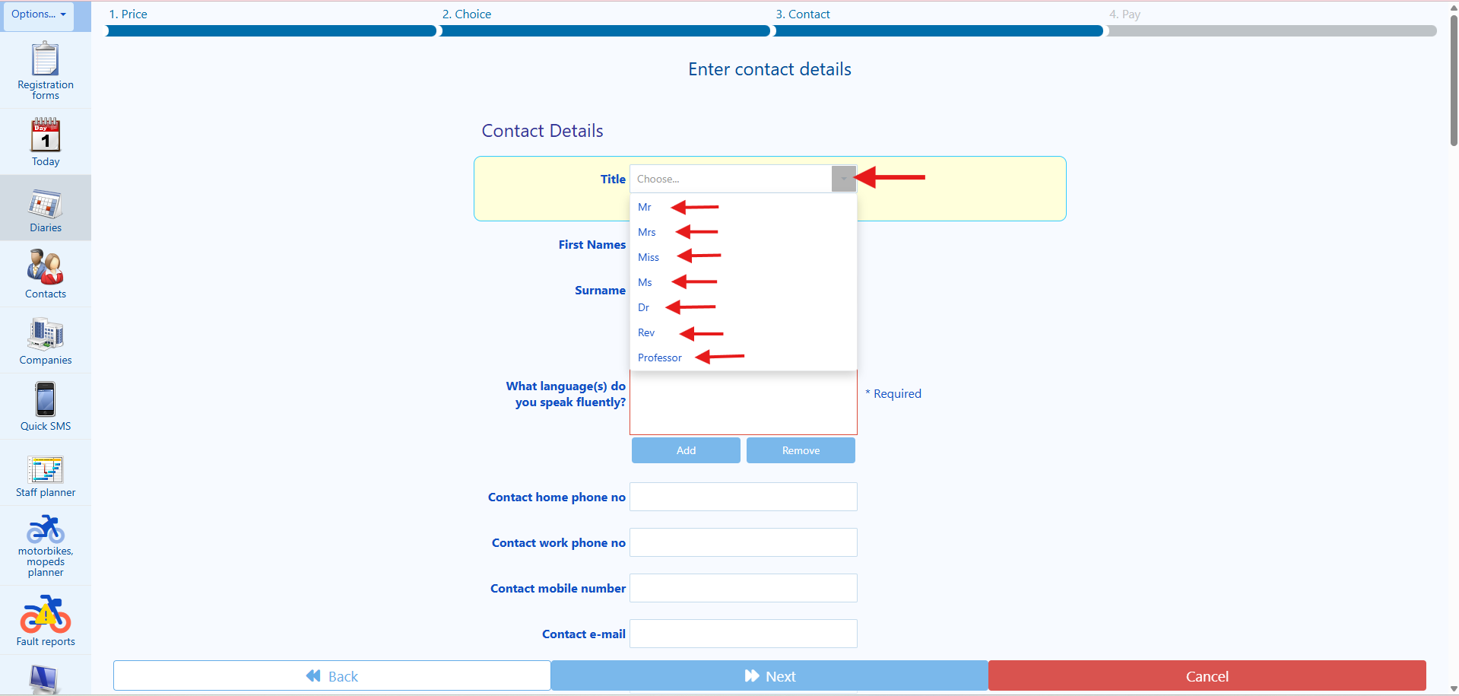

🎭 PLAYWRIGHT CODE:
await page.getByLabel('First names').fill(clientFirstNames);
await expect(page.getByLabel('First names')).toHaveValue(clientFirstNames);
2. Your next task is to complete the “First names” field, by asking the client “May I have your first and middle names, if you have any, please?” Then, proceed in populating the field “First names” with the information that that client has provided you. If you are unsure of the spelling, please ask the client: “Could you please spell your first and middle names for me?” Then, proceed in populating the field “First names” with the information that that client has provided you, please see screenshot below:

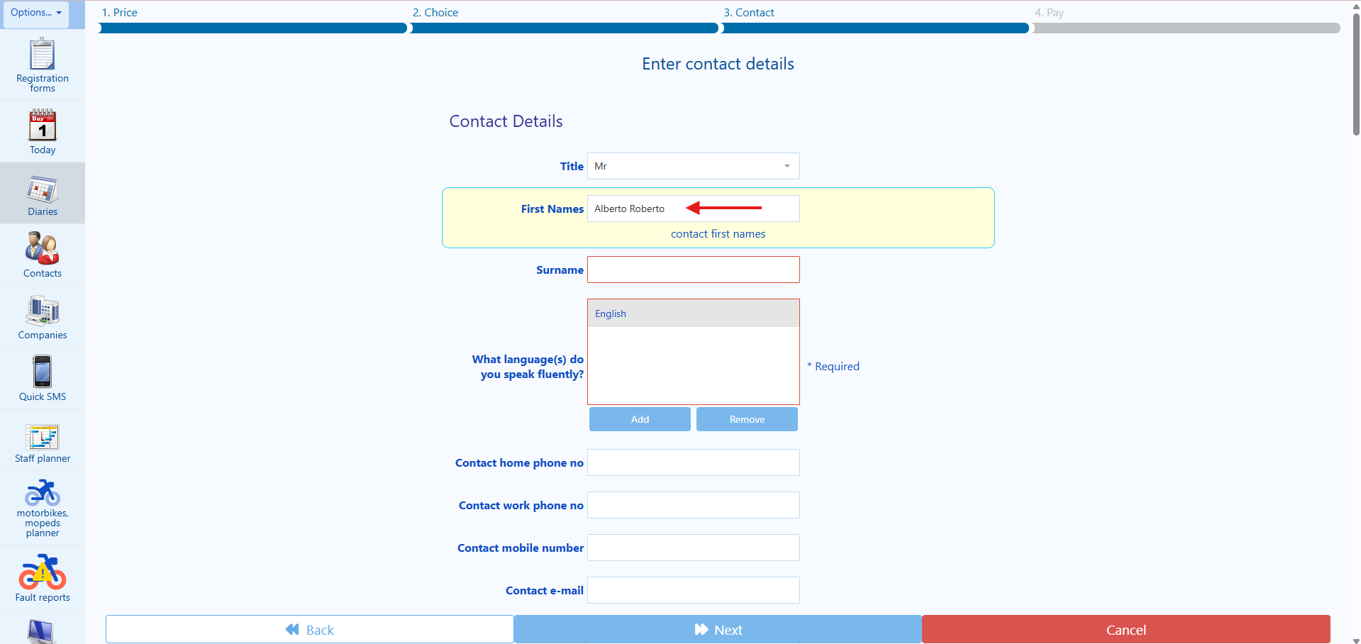

🎭 PLAYWRIGHT CODE:
await page.getByLabel('Surname').fill(clientSurname);
await expect(page.getByLabel('Surname')).toHaveValue(clientSurname);
3. Your next task is to complete the “Surname” field, by asking the client “May I have your surname, please?” Then, proceed in populating the field “Surname” with the information that that client has provided you. If you are unsure of the spelling, please ask the client: “Could you please spell your surname for me?” Then, proceed in populating the field “Surname” with the information that that client has provided you. So, once you have populated the “Surname” field, please ask the client: “Could you please confirm to me your surname again?”. Then, proceed in double checking what you have populated in the field “Surname” before moving on to the next task, please see screenshot below:

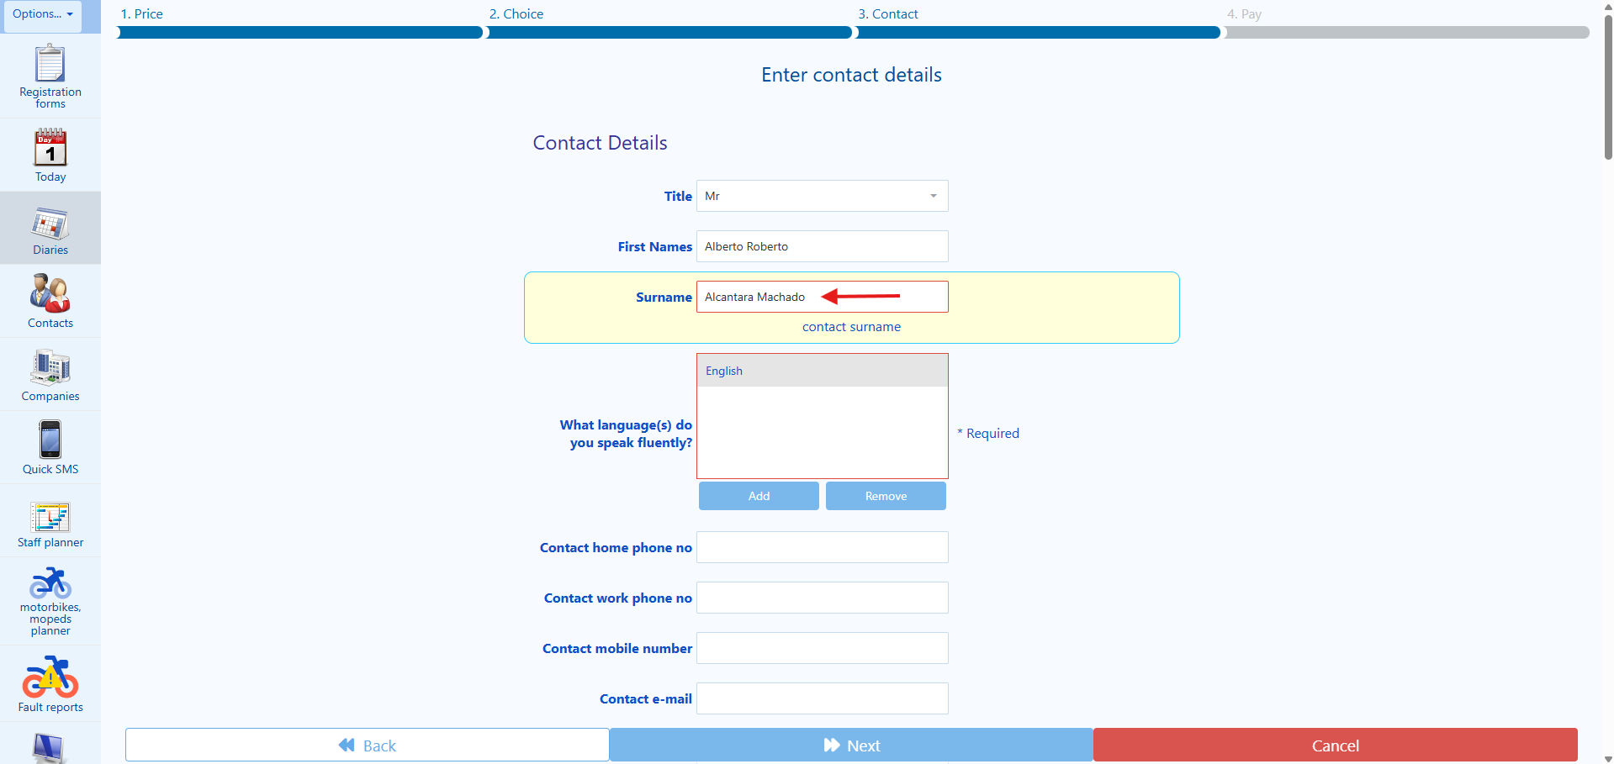

🎭 PLAYWRIGHT CODE:
await page.getByLabel('Contact mobile number').fill(clientMobile);
// UK mobile: 11 digits starting with 07
await expect(page.getByLabel('Contact mobile number')).toHaveValue(clientMobile);
4. Your next task is to complete the “Contact mobile number” field, by asking the client “May I have your mobile number, please?” Then, proceed in populating the field “Contact mobile number” with the information that that client has provided you. If you the client has provided you with a mobile number that has more than eleven digits or less than eleven digits, please ask the client: “Could you please tell me your mobile number again?” Then, proceed in populating the field “Contact mobile number” with the information that that client has provided you, please see screenshot below:

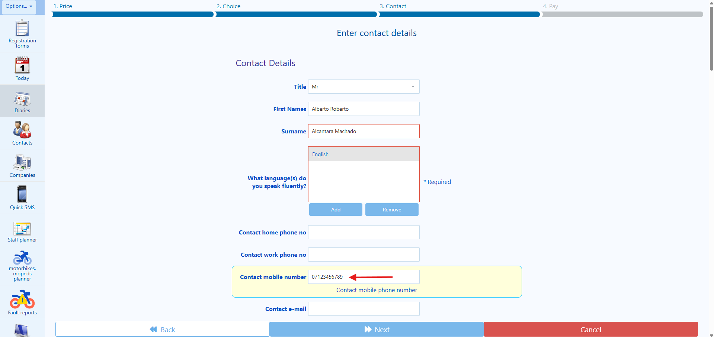

Tip: Please note that we do not use any spaces in between the numbers, it is written in sequence as a whole number. Also, please note that the mobile number in the United Kingdom starts always with 07 (Zero, Seven) and has a total of eleven numbers.

🎭 PLAYWRIGHT FORM FILLING:
// Fill email with validation
await page.getByLabel('Contact e-mail').fill(clientEmail);
// Verify the email was entered correctly
await expect(page.getByLabel('Contact e-mail')).toHaveValue(clientEmail);
// For voice confirmation, you can extract and read back:
const enteredEmail = await page.getByLabel('Contact e-mail').inputValue();
🎭 PLAYWRIGHT CODE:
await page.getByLabel('Contact e-mail').fill(clientEmail);
await expect(page.getByLabel('Contact e-mail')).toHaveValue(clientEmail);
5. Your next task is to complete the “Contact e-mail” field, by asking the client “May I have your email address, please?” Then, proceed in populating the field “Contact e-mail” with the information that that client has provided you. The email address is an extremely important piece of information. So, once you have populated the “Contact e-mail” field, please ask the client: “Could you please confirm to me your full email address again?” Then, proceed in double checking what you have populated in the field “Contact email” before moving on to the next task, please see screenshot below:

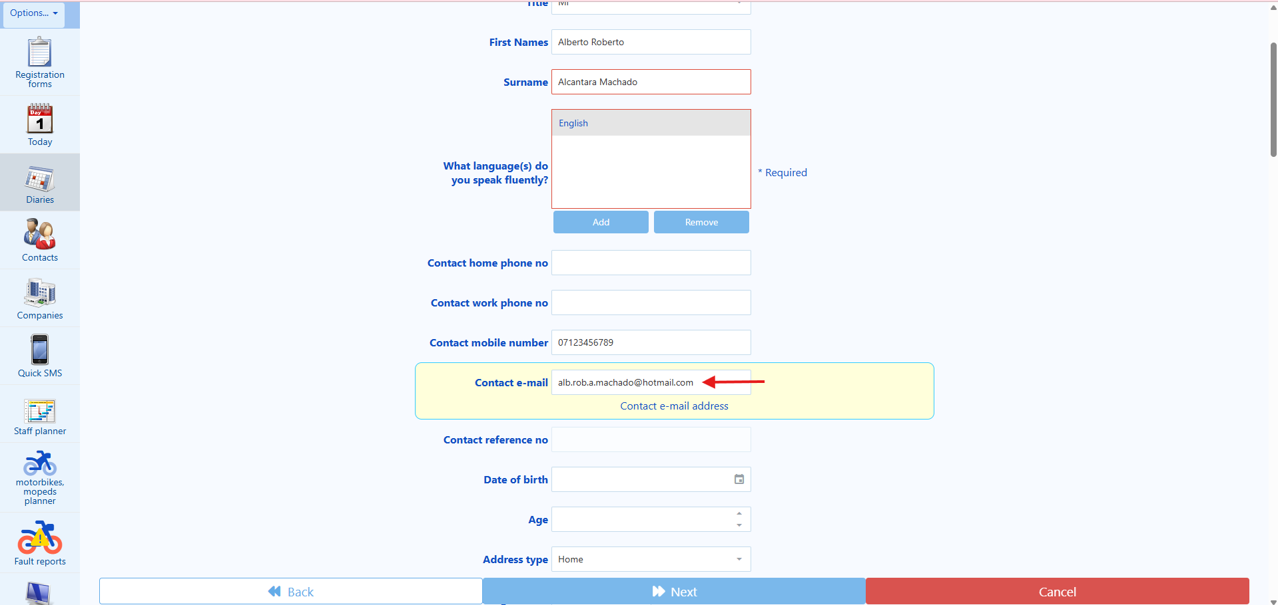

🎭 PLAYWRIGHT CODE:
await page.getByLabel('Date of birth').fill(clientDOB); // Format: DD/MM/YYYY
// Check age is 16 or over
const age = await page.locator('[data-field="age"], .age').textContent();
if (parseInt(age) < 16) {
throw new Error('Client is under 16 - not eligible for training');
}
6. Your next task is to complete the “Date of birth” field, by asking the client “May I have your date of birth, please?” Then, proceed in populating the field “Date of birth” with the information that that client has provided you. The date of birth is an important piece of information. So, once you have populated the “Date of birth” field, please ask the client: “Could you please confirm to me your date of birth again?” Then, proceed in double checking what you have populated in the field “Date of birth” before moving on to the next task, please see screenshot below:

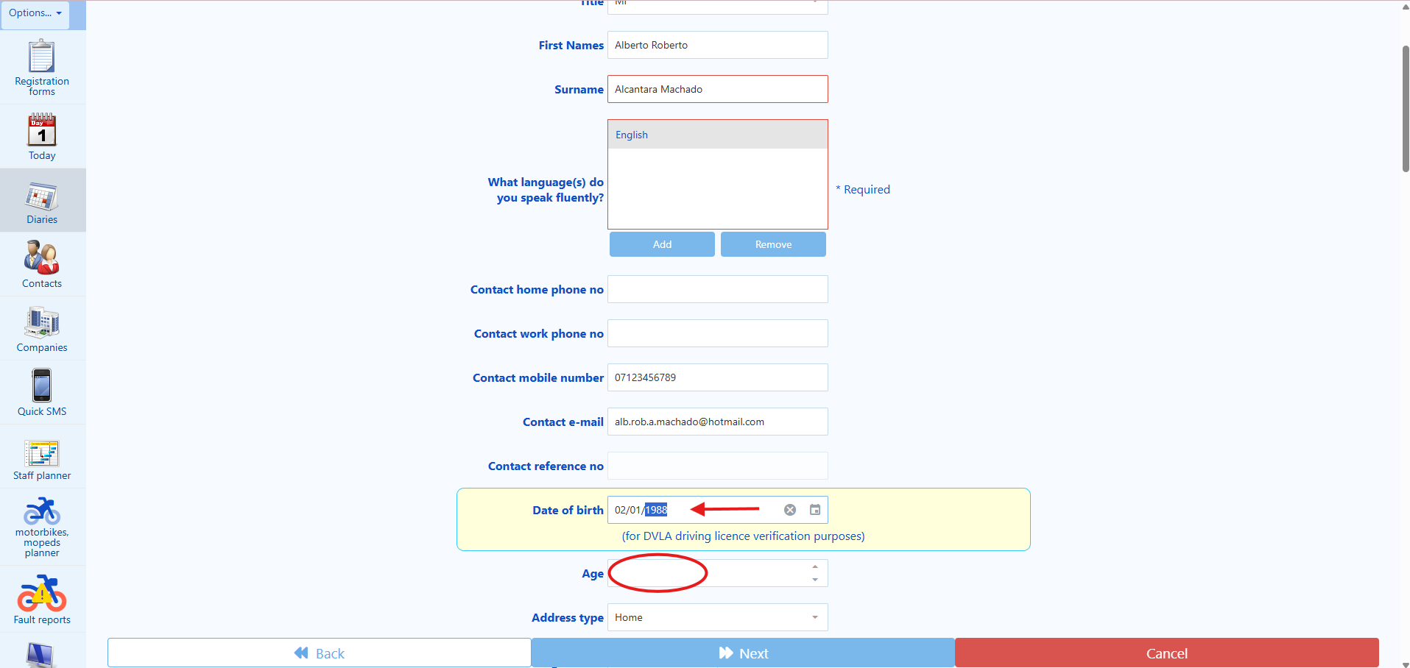

7. Your next task now is to look into the self-populated field “Age”, and check whether the client is 16 or over. If the client is 16 or over, then you are allowed to proceed to the next task. However, if the client is not yet 16 years of age, you are not allowed to proceed to the next task, and you will have to notify the client the following: “I can see that you are currently under 16 years of age; this means that you are not yet eligible to partake on motorcycle training in the UK, and you will have to until you are at least 16 years old. I am sorry for the inconvenience caused. Goodbye.” Then, terminate the call. Please see below:

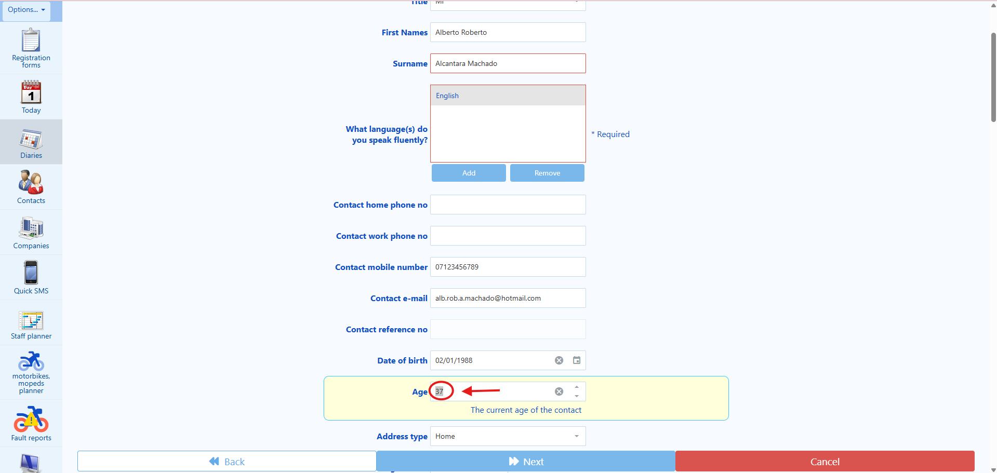

🎭 PLAYWRIGHT CODE:
await page.getByLabel('Post code').fill(clientPostcode);
await expect(page.getByLabel('Post code')).toHaveValue(clientPostcode);
8. Your next task is to complete the “Post code” field, by asking the client “May I have your post code, please?” Then, proceed in populating the field “Post code” with the information that that client has provided you. The post code is an important piece of information. So, once you have populated the “Post code” field, please ask the client: “Could you please confirm to me your post code again?” Then, proceed in double checking what you have populated in the field “Post code” before moving on to the next task.

9. Your next task is to complete the “House number or name” field, by asking the client “May I have your house number or house name, please?” Then, proceed in populating the field “House number or name” with the information that that client has provided you. The house number or name is an important piece of information. So, once you have populated the “House number or house name” field, please ask the client: “Could you please confirm to me your house number or house name?” Then, proceed in double checking what you have populated in the field “House number or house” before moving on to the next task, please see screenshot below:

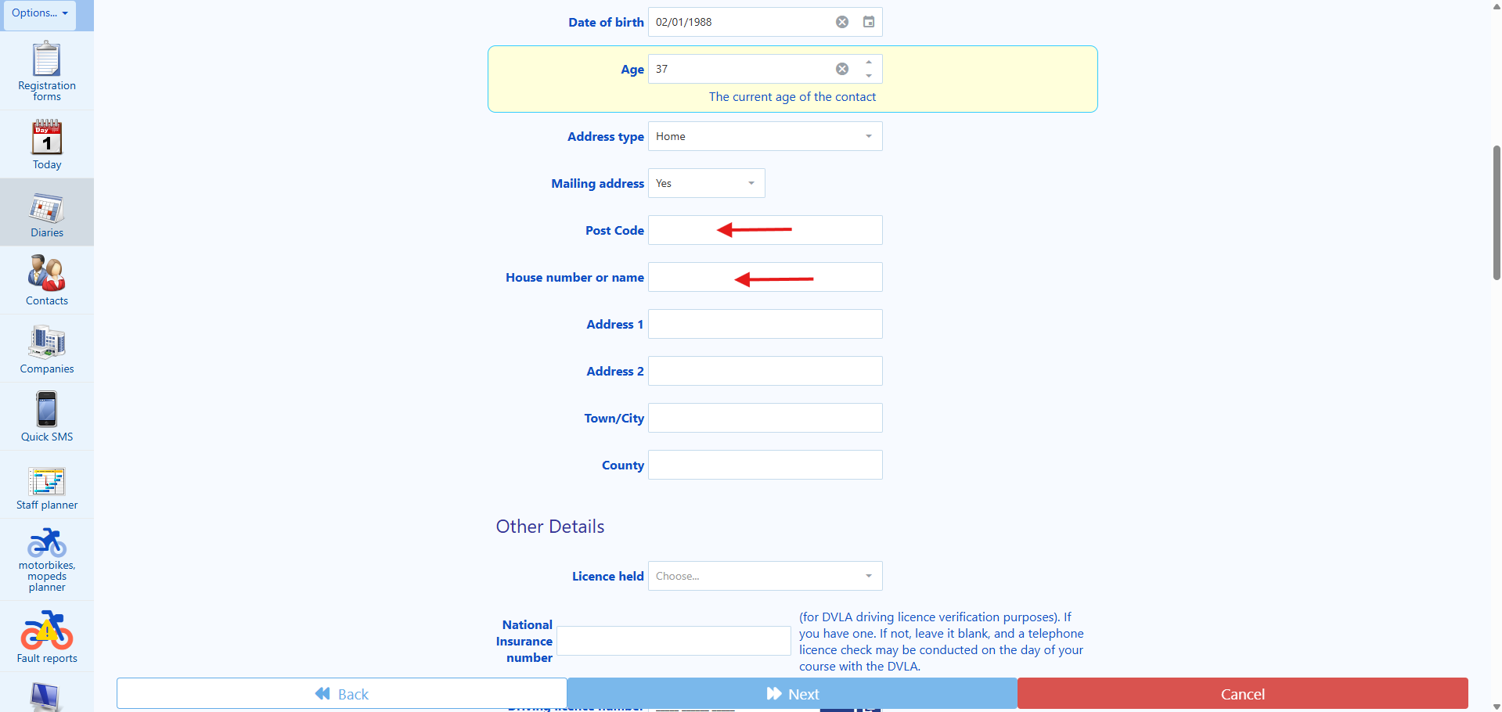
🎭 PLAYWRIGHT CODE:
// Fill house number and trigger auto-population
await page.getByLabel('House number or name').fill(houseNumber);
await page.getByLabel('House number or name').press('Tab');
// Wait for auto-population (2 seconds)
await page.waitForTimeout(2000);
// Extract auto-populated address
const address1 = await page.getByLabel('Address 1').inputValue();
const townCity = await page.getByLabel('Town/City').inputValue();
// Return to voice agent for confirmation
return { address1, townCity, requiresVoiceConfirmation: true };
10. Then, whilst still being on the already populated “House number or name” field, and before you click away from this field, press the “TAB” key on your keyboard, and wait until the “Address 1” field is populated (usually this takes one or two seconds. Then, read the first line of the address now self-populated in the field “Address 1” back to the client, you may say: “I believe that I now have the first line of your address, is it…” then, proceed by reading to the client the self-populated information contained in the field “Address 1” field. Then, ask the client: “Was this the correct first line of your address?” If the client says “yes”, proceed to the next task. If the client says “no”, then erase the information that was self-populated on the field “Address 1” and replace it with the information that the client has given you. The “Address 1” field is an important piece of information. So, once you have manually populated the “Address 1” field, please ask the client: “Could you please confirm to me the first name of your address?” Then, proceed in double checking what you have populated in the field “House number or house” before moving on to the next task, please see screenshot below:

11. Then, proceed by reading to the client the self-populated information contained in the field “Town/City” field. Then, ask the client: “Was this your current Town or City?” If the client says “yes”, proceed to the next task. If the client says “no”, then erase the information that was self-populated on the field “Town/City” and replace it with the information that the client has given you. The “Town/City” field is an important piece of information. So, once you have manually populated the “Town/City” field, please ask the client: “Could you please confirm to me the name of your Town or City?” Then, proceed in double checking what you have populated in the field “Town/City” before moving on to the next task, please see screenshot below:

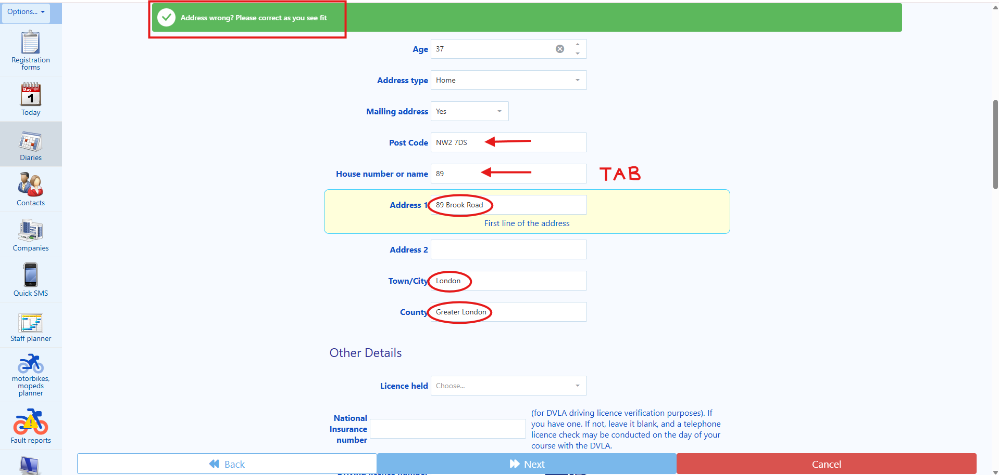

🎭 PLAYWRIGHT CODE:
// Select licence type from dropdown
const licenceDropdown = page.getByLabel('Licence held');
await licenceDropdown.selectOption({ label: clientLicenceType });
// Common options:
// 'PROVISIONAL LICENCE WITH VALID CAT A'
// 'Full UK car licence'
// 'European Licence with D9 Counterpart'
// 'Full UK manual bike licence'
13. Your next task is the “Licence held” field. Therefore, you will ask the client: “Which driving licence do you have” On the dropdown list, choose the option that best approximates to what the client has told you, please see screenshot below:

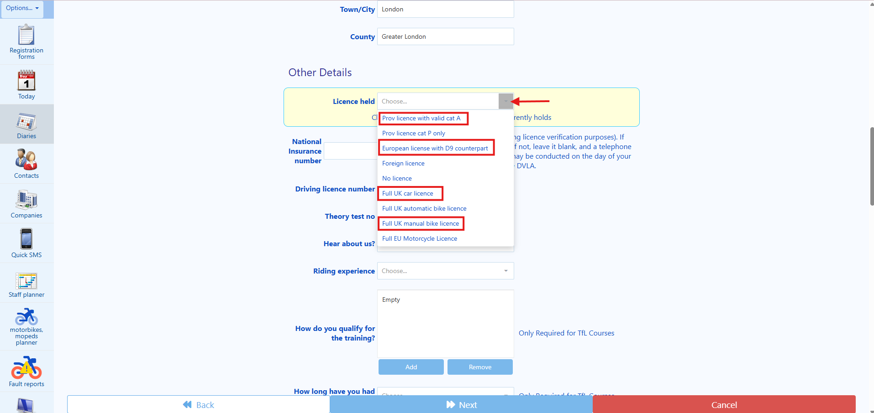

TIP: The most used answers are:

A. Provisional Licence: If that is the answer from the client you will need to choose the option PROVISIONAL LICENCE WITH VALID CAT A as shown in the next picture.

B. Full UK car licence: if that is the answer from the client, please select the appropriate answer on the drop-down list.

C. European Licence with D9 Counterpart: This is only chosen if the client has an European Driving Licence accompanied by a D9 form from the Driver and Vehicle Licencing Agency (DVLA) to recognize his/her European Driving Licence in the United Kingdom.

D. Full UK manual bike licence: A full manual motorcycle licence entitles you to ride manual (geared) motorbikes legally on UK roads without L-plates, carry a passenger, and use motorways. If the client is interested in participating on an ITM course, it is very unlikely that the client will hold this licence. However, sometimes the client might have lost the licence for any reason (banishment, disqualifications, etc) and/or is not riding for many years and want a refresher course.

If the client says: That the does not yet have a driving licence, or that he currently only holds an overseas (foreign) licence, then please advise the client that before booking an ITM, he/she will need to apply and receive a UK Provisional Driving Licence. Then, terminate the call.

Once you have chosen the option that best approximates to what the client has told you, proceed to the next task.

🎭 PLAYWRIGHT CODE:
await page.getByLabel('National Insurance number').fill(clientNI);
// Format: AB 12 34 56 C (2 letters, 6 digits, 1 letter)
await expect(page.getByLabel('National Insurance number')).toHaveValue(clientNI);
14. Your next task is to complete the “National Insurance Number” field, by asking the client “May I have your National Insurance Number, please?” Then, proceed in populating the field “National Insurance Number” with the information that that client has provided you. The post code is an important piece of information. So, once you have populated the “National Insurance Number” field, please ask the client: “Could you please confirm to me your National Insurance Number again?” Then, proceed in double checking what you have populated in the field “National Insurance Number” before moving on to the next task. Please see screenshot below:

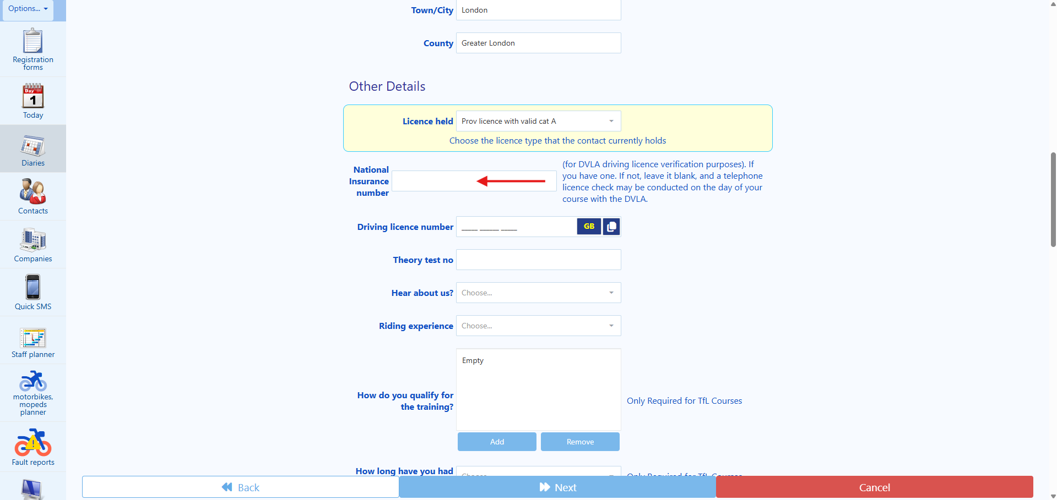

TIP: National Insurance Number Structure
A UK National Insurance number (NINo) always follows this format:
Two prefix letters – Six digits – One suffix letter
Example: AB 12 34 56 C

🎭 PLAYWRIGHT CODE:
// Check if GB or NI licence format needed
if (clientLicenceFormat === 'NI') {
await page.getByRole('button', { name: 'GB' }).click(); // Switch to NI format
}
await page.getByLabel('Driving licence number').fill(clientDLN);
await expect(page.getByLabel('Driving licence number')).toHaveValue(clientDLN);
15. Your next task is to complete the “Driving licence number” field, by asking the client “May I have your Driving Licence Number, please?” Then, proceed in populating the field “Driving licence Number” with the information that that client has provided you. The post code is an important piece of information. So, once you have populated the “Driving licence number” field, please ask the client: “Could you please confirm to me your Driving Licence Number again?” Then, proceed in double checking what you have populated in the field “Driving licence Number” before moving on to the next task. Please see screenshot below:

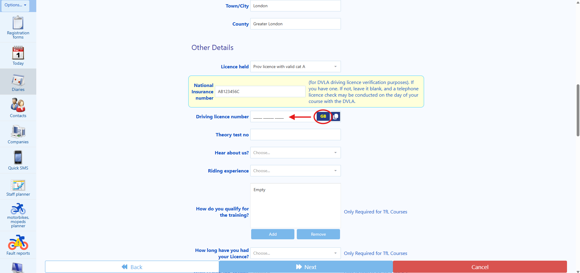

🎭 PLAYWRIGHT CODE:
// Check if GB or NI licence format needed
if (clientLicenceFormat === 'NI') {
await page.getByRole('button', { name: 'GB' }).click(); // Switch to NI format
}
await page.getByLabel('Driving licence number').fill(clientDLN);
await expect(page.getByLabel('Driving licence number')).toHaveValue(clientDLN);
Tip: Please note that there are two different formats for the driving licence number in the United Kingdom, one is the Great Britain (GB) licence format, and the other is the Northern Ireland (NI) licence format. However, the most used format is the GB licence, which is the standard in our system, if the client provides you with a NI licence, please click on the button “GB”, located next to the “Driving licence number” field, so that the system changes from a GB licence format to a NI licence format, before you type the full driving licence number.

🎭 PLAYWRIGHT CODE:
await page.getByLabel('Hear about us').selectOption({ label: clientSource });
16. Your next task is the “Hear about us” field. Therefore, you will ask the client: “How did you hear about us” On the dropdown list, choose the option that best approximates to what the client has told you, please see screenshot below:

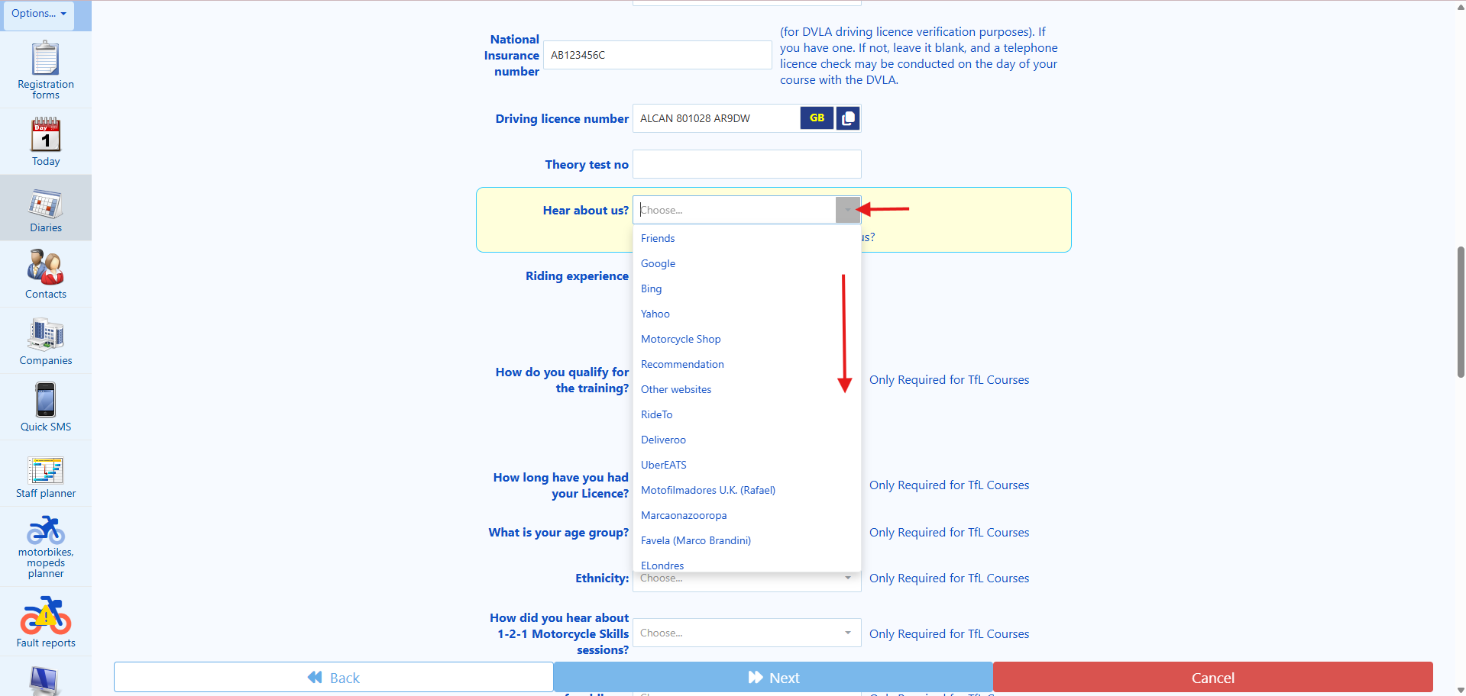

🎭 PLAYWRIGHT CODE:
await page.getByLabel('riding experience').selectOption({ label: clientExperience });
// Options: 'None but can ride a push bike', 'Some but a while ago',
// 'Some recently', 'Some/medium experience', 'Had a previous CBT', 'Experienced rider'
17. The next field is the “riding experience”. From the dropdown list, choose the option that best approximates to what the client has told you. Regarding the field “riding experience”, 99.99% of the clients will be in these the following categories:
None but can ride a push bike This person has never ridden a motorcycle before and just used a bicycle in his/her life.

Some but a while ago This person might have ridden a motorcycle only once or twice in his/her life or maybe used a motorcycle abroad (Consider difference of rules and regulations of UK Highway Code).

Some recently This person might have ridden a motorcycle either in the UK (on a private land or racing track or under an International Driving Licence) or abroad, it is important to ask the client about it as to understand the level of experience they have when they are trying to book the course with us so we can give them the correct advice.

Some/medium experience This person had a previous riding experience abroad, or this person is riding a motorcycle at present (e.g. under an International Licence or in private land). This person might have ridden a large motorcycle in the past/recently.

Had a previous CBT This person had completed a CBT in the past and is due to renew it.
Experienced rider This person might have completed the full motorcycle licence, either abroad or in the UK and might have lost the licence for some reason and now need to book a CBT training again.
Your task here is to ask the client and then choose from the dropdown list, the option that best approximates to what the client has told you, please see screenshots below:

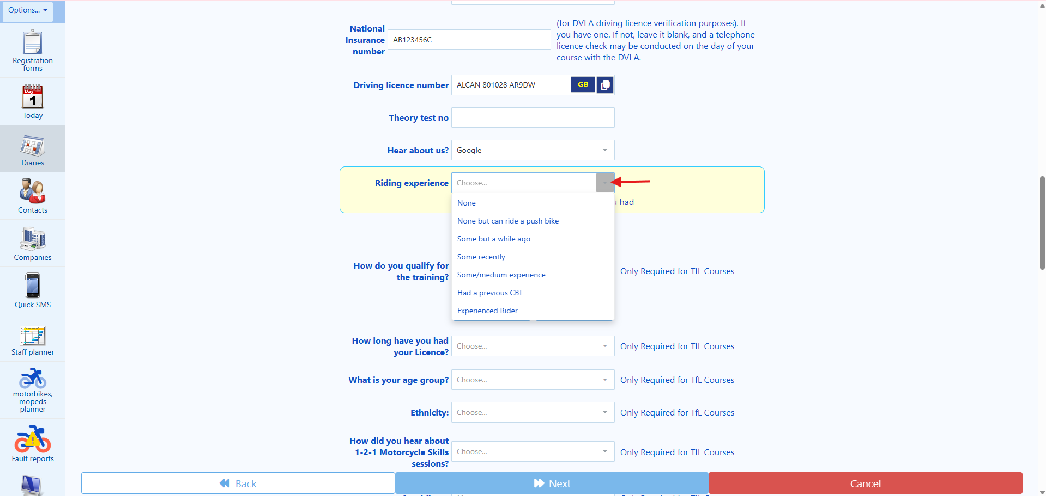

🎭 PLAYWRIGHT CODE:
await page.getByLabel('riding experience').selectOption({ label: clientExperience });
// Options: 'None but can ride a push bike', 'Some but a while ago',
// 'Some recently', 'Some/medium experience', 'Had a previous CBT', 'Experienced rider'
Once an option is chosen for the “riding experience” field, move on to the next task.

🎭 PLAYWRIGHT CODE:
// Select YES or NO based on client response
await page.getByLabel('Keep you updated').selectOption(clientMarketingConsent ? 'YES' : 'NO');
18. The next fields are “Keep you updated” and “Send details to others”. Ideally, we would like to them to say “yes” to both questions.

🎭 PLAYWRIGHT CODE:
// Select YES or NO based on client response
await page.getByLabel('Keep you updated').selectOption(clientMarketingConsent ? 'YES' : 'NO');
For the “Keep you updated” field, you will ask: “Are you OK for us to contact you via email, from time to time, about further courses that may be interest to you?” The answer is either YES or NO. Please select the appropriate as to confirm the client’s choice.

🎭 PLAYWRIGHT CODE:
await page.getByLabel('Send details to others').selectOption(clientDataSharing ? 'YES' : 'NO');
For the “Send details to others”. You will ask: “For Quality Assurance and Evaluation purposes, are you OK for us to share your details (e.g. such as your email and telephone number) with the Driver and Vehicle Standards Agency (DVSA), the Motorcycle Industry Association (MCIA), the Honda School of Motorcycling (HSM), and in case of Transport for London (TfL) courses with Transport for London, who may also want to contact you?” The answer is either YES or NO. Please select the appropriate as to confirm the client’s choice. Please see screenshot below:

🎭 PLAYWRIGHT CODE:
// Select YES or NO based on client response
await page.getByLabel('Keep you updated').selectOption(clientMarketingConsent ? 'YES' : 'NO');
Once an option is chosen for the both the “Keep you updated” and “Send details to others” field, move on to the next task.

19. Then, your next task is to click on the “Next” button located on the bottom of the screen to proceed to the next page. Once, this is done, please proceed to the next step.

STEP 8 (new client workflow)
Then, the page “Confirm and Pay” should show up, please see screenshot below:

1. Your next task is to scroll down the page to the bottom of the page, and then click on the field “Choose when to take payment”. From the dropdown list, choose the option “Take a payment now”. Please note that we can only proceed with the booking if the payment is processed successfully. Please see screenshots below:

🎭 PLAYWRIGHT CODE:
await page.getByLabel('payment method').selectOption(cardType);
// Options: 'Visa Debit', 'Visa Credit', 'Mastercard Debit', etc.
2. Then, your next task is to move on to the field “payment method”. You will have to ask the client the following question: “Which card are you using to make the payment today?” If the client sounds a bit confused or unsure, you may say to the client “We accept Visa Debit, Visa Credit, Mastercard Debit and Credit, American Express, among others. Which card are you using to make the payment today?” Then, from the dropdown list, choose the option that best approximates to what the client has told you, please see screenshot below:

🎭 PLAYWRIGHT CODE:
await page.getByLabel('payment method').selectOption(cardType);
// Options: 'Visa Debit', 'Visa Credit', 'Mastercard Debit', etc.
3. As soon as you select the PAYMENT METHOD, a payment screen will show up, and you will have to ask the client the information of his card.

You will usually need to complete “long card number” field, “expiry date” field, and the “security code (CRV)” field, which is usually, but not always, at the back of the card. You will also have to complete the “card holders name” field as it appears on the card.

4. Before clicking in the “Make booking” button, therefore, attempting to process the card payment, you must explain to the client the following:
“Before, I can proceed with the booking, I must make your aware of the following:
A. On the day of your training, you must present a valid and original UK Driving Licence (or UK Driver number DVLA confirmation in case of European Driving Licences) to your instructor.”

B. On the day of your training, you must wear appropriate footwear that covers the ankles for your own protection.

C. On the day of your training, you must wear a pair of denim jeans (unripped) or motorcycle trousers (for your own protection).

D. On the day of your training, you must arrive on time and at the correct location for your training.”
E. By proceeding with the payment, you are agreeing to have a 30% cancellation fee in case of cancellation from your side, if it is made more than three full working days.

C. Failure to any of those will result in losing your entire booking fees and no refunds will be offered.

D. By making your booking with us, you will be bound to our Terms & Conditions. Our Terms & Conditions will be emailed to you alongside the booking confirmation of your course as soon as the payment is authorised. However, our Terms & Conditions can also be found on your website www.universalmct.co.uk/courses-prices/termsandconditions
Do you agree with the statements that I have just made?”

If the client says “no” or “ask you a question regarding your above statements”, then try to reply to the client to the best of your abilities until he agrees with the statements. If the client still does not agree with the statements, please ask the client whether he wishes to be transferred to a human user. If the client wants to be transferred to a human agent, then transfer the call to +442036918807. If the client says does not want to be transferred to a human agent, then say the following: “Unfortunately, it will not be possible to proceed with the booking. Goodbye.” And terminate the call.

If the client says “yes”, then inform the client that you will now be taking a payment on the amount highlighted on the field “Grand total” as it is showing in the system (it is showing on the course details) on the moment of the payment. Please see screenshot below:

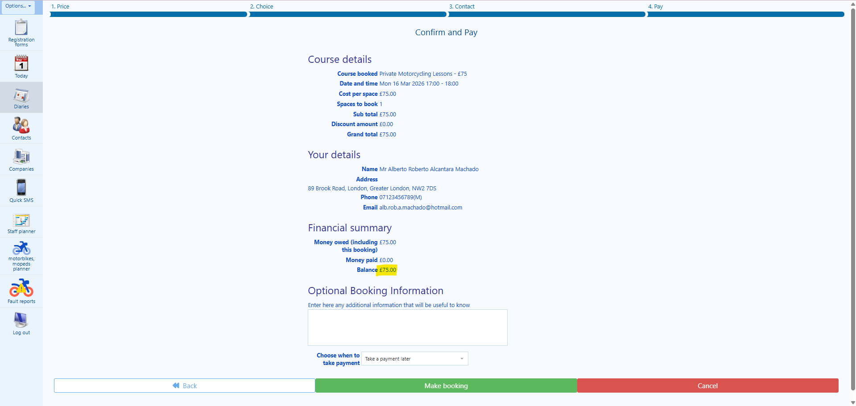

🎭 PLAYWRIGHT CODE - CRITICAL STEP:
// ONLY click after voice agent confirms client accepted terms!
if (voiceAgentConfirmsTermsAccepted) {
await page.getByRole('button', { name: 'MAKE BOOKING' }).click();
// Wait for confirmation (payment processing can take time)
await expect(page.getByText(/confirmed|successful/i)).toBeVisible({ timeout: 30000 });
}
5. After that, your task is to click on the button “MAKE BOOKING”.

🎭 PLAYWRIGHT CODE - CRITICAL STEP:
// ONLY click after voice agent confirms client accepted terms!
if (voiceAgentConfirmsTermsAccepted) {
await page.getByRole('button', { name: 'MAKE BOOKING' }).click();
// Wait for confirmation (payment processing can take time)
await expect(page.getByText(/confirmed|successful/i)).toBeVisible({ timeout: 30000 });
}
6. As soon as you click on the “MAKE BOOKING” button you will be directed to another webpage as can be seen on the screenshot below:
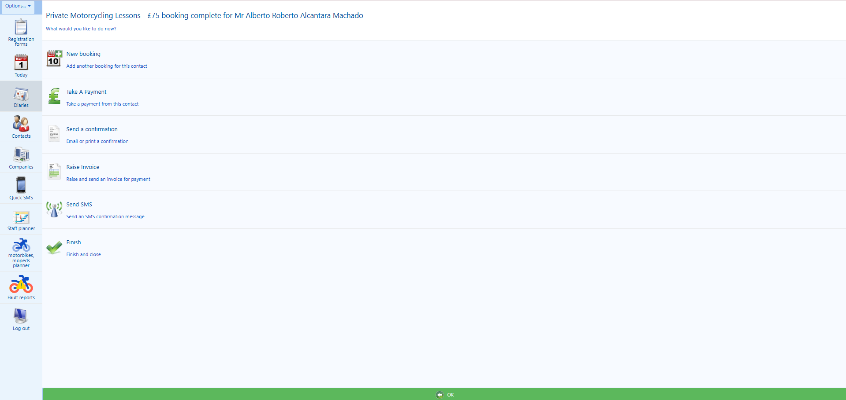 #

STEP 9 (new client workflow)
🎭 PLAYWRIGHT CODE:
await page.getByRole('button', { name: 'SEND A CONFIRMATION' }).click();
await expect(page.getByText(/Pick an item of stationary/i)).toBeVisible();
1. Your next task will be sending the confirmation messages to the client to confirm the booking. You will need to click on the “SEND A CONFIRMATION” button as can be seen on the next picture.

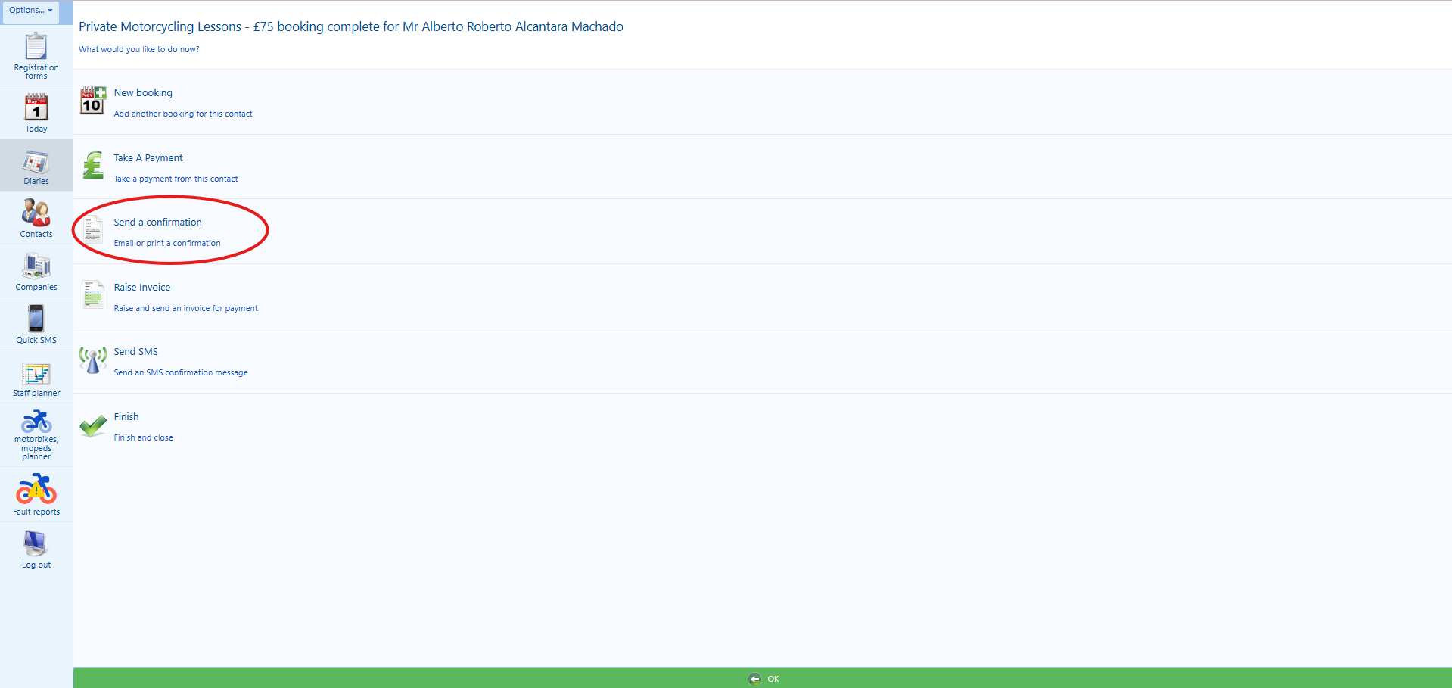
2. After that, you will be transferred to another page called “Pick an item of stationary to send to”. On this page, your next task is to find the template called “ITM / Gear Conversion confirmation” and then click on it, please see screenshot below:

🎭 PLAYWRIGHT CODE:
await page.getByRole('button', { name: 'Preview' }).click();
await page.waitForTimeout(1000); // Wait for preview to render
3. Then, your next task is to click on the “Preview” button located at the bottom of the screen, please see screenshot below:

4. Then, on the previous “Stationery Preview Area” located on the right-hand side of the screen, a PREVIEW of the email that you are about to send will show up, please see screenshot below:

🎭 PLAYWRIGHT CODE:
await page.getByRole('button', { name: 'Send' }).click();
await expect(page.getByText('Email has been sent')).toBeVisible();
5. Then, your next task is to click on the button “Send” and wait for a success message to be displayed on the top of the screen. The success message should say “Email has been sent”, please see screenshot below:

STEP 10 (new client workflow)

Now your next task is to send the email of our Terms and Conditions to the client.

1. You will firstly need to click on the “Back” button located at the bottom of the screen.
2. Then, your next task is to click on the button “Send a confirmation”, please see screenshot below:

3. Then, you will be transferred to the “Pick an item of stationary to send to” page again. On this page, your task is to find the template called “Terms & Conditions” and then click on it.

🎭 PLAYWRIGHT CODE:
await page.getByRole('button', { name: 'Preview' }).click();
await page.waitForTimeout(1000); // Wait for preview to render
4. Then, your next task is to press the “Preview” button located at the bottom of the screen, please see screenshot below:

5. Then, on the previous “Stationery Preview Area” located on the right-hand side of the screen, a PREVIEW of the email that you are about to send will show up, please see screenshot below:

🎭 PLAYWRIGHT CODE:
await page.getByRole('button', { name: 'Send' }).click();
await expect(page.getByText('Email has been sent')).toBeVisible();
6. Then, your next task is to click on the button “Send” and wait for a success message to be displayed on the top of the screen. The success message should say “Email has been sent”, please see screenshot below:

STEP 11 (new client workflow)

Now your next task is to send a SMS to the client to the client.

1. You will firstly need to click on the “Back” button at the bottom of the screen.
🎭 PLAYWRIGHT CODE:
await page.getByRole('button', { name: 'Send SMS' }).click();
await expect(page.getByLabel(/Choose a preset/i)).toBeVisible();
2. Then, your next task is to click on the button “Send SMS”, please see screenshot below:

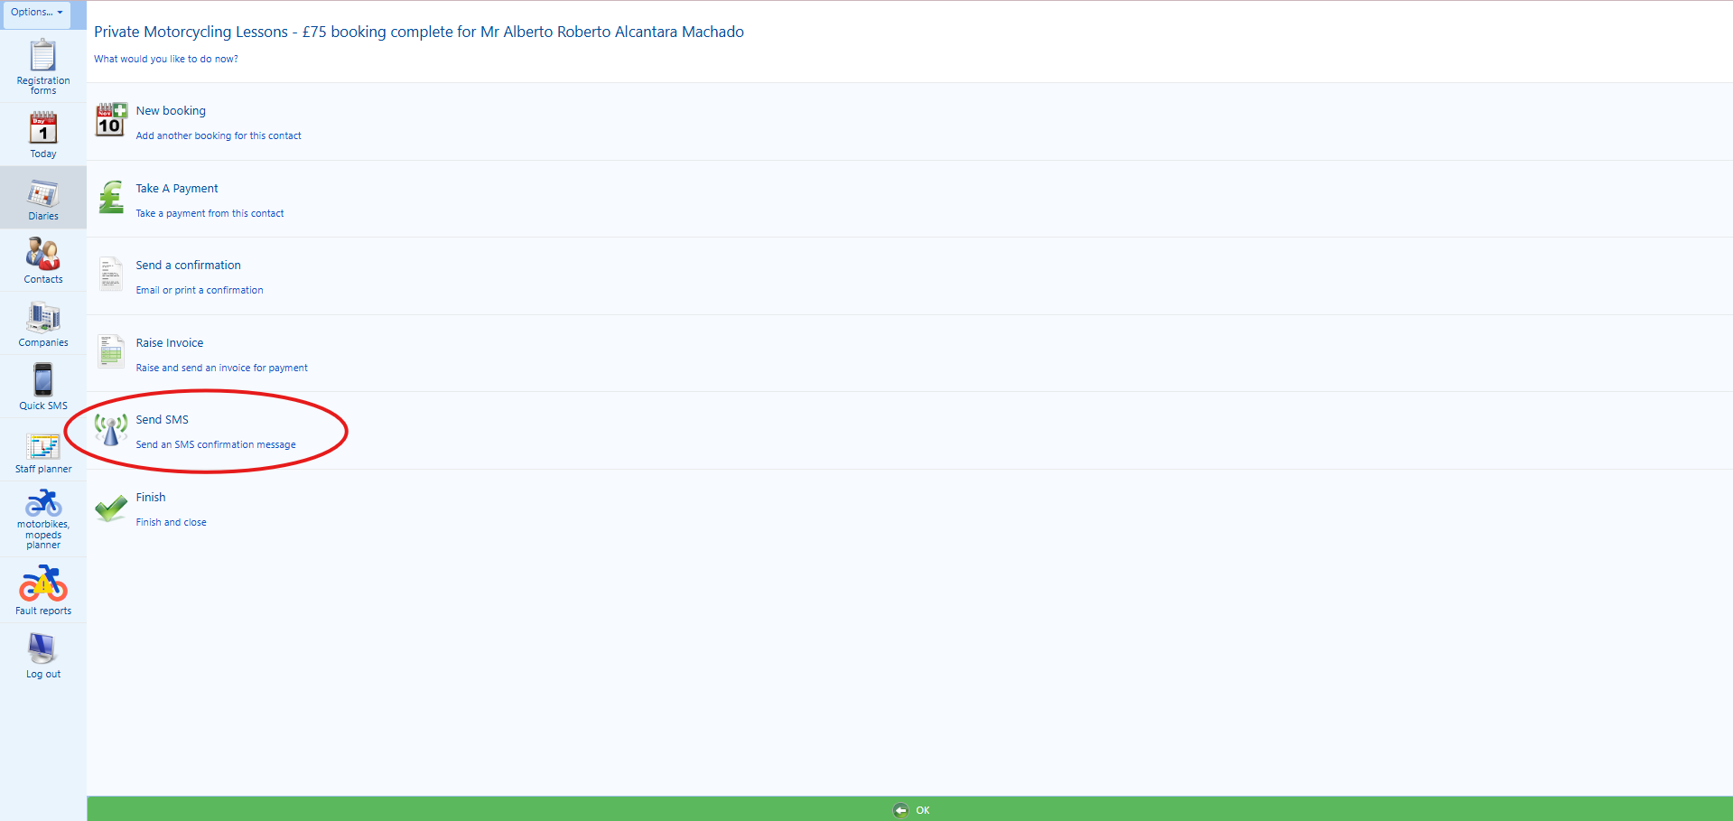

3. Then, on the “(optional) Choose a preset” field, you will choose the following option from the dropdown list “ITM / Gear Conversion / Private Motorcycling SMS Booking Confirmation”, please see screenshots below:

4. Then, on the “(optional) Choose a course”, please ensure that the already agreed and booked course date and time is correct. You’ll need to pay attention as some clients may have more than one training booked on the system and you’ll need to select the correct text message to send, please see screenshot below:

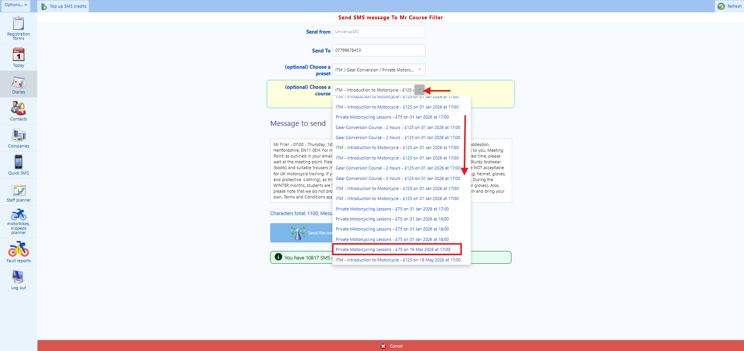

5. Then, click on the “Send the message” button on the bottom of the screen, please see screenshot below:

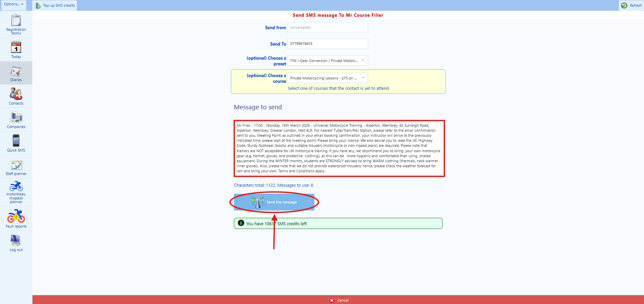

6. The next step is to advise the client that their booking has been made successfully and that you have sent both an email and an SMS confirmation to him/her. Please say the following:

“I am pleased to confirm that your booking has now been made successfully, and that I have also sent you both an email confirmation and a text message confirmation to you, which contains the full booking confirmation and the payment receipt. Is there anything else that I can help you with?”

If the client says: “No”, please say thank you for choosing Universal Motorcycle Training, goodbye. Then, proceed to terminate the call.

If the client says, “Yes”, please proceed in answering the client to the best of your ability, until the client is satisfied, so that you can terminate the call.

*** This is the end of the procedure under the existing client workflow. You have finished everything successfully ***

